


Homelessness insights

June 2025

Contents
Contents 1
Introduction 2
Key messages 2
Common themes we’ve heard from councils 3
2023 Census living without shelter estimates 4
Demographic breakdowns of those living without shelter 4
New insights from the 2023 severe housing deprivation estimates 5
Observations from the sector 5
Figures from around the country 6
Ministry-funded outreach services 7
Specialist mental health and addictions 8
Rangatahi supported through Oranga Tamariki 9
Emergency housing 9
Transitional housing 11
Housing register 12
Housing First – waiting to be housed 13
Broader system insights that may be affecting homelessness 14
Lack of employment 14
Population growth 14
Rental inflation 14
Availability of appropriate housing 14
Residential construction 15
Family violence 15
Alcohol, drugs and other substances 15
How the system is responding to homelessness 15
Research and reports of interest 16

Introduction
This report aims to provide insights into homelessness using a range of data and observational reports. The focus of this report is on those living without shelter, however, where possible we have included information regarding all categories of homelessness. Where available, data has been presented to March 2025, however some data sources have a lag.
Homelessness is defined as living situations where people with no other options to acquire safe and secure housing: are without shelter, in temporary accommodation, sharing accommodation with a household or living in uninhabitable housing.
The most robust estimates of homelessness are severe housing deprivation estimates from the five-yearly Census. These suggest there were at least 112,500 people who were severely housing deprived on 7 March 2023, including 4,965 people estimated to be living without shelter.

Key messages
- The most robust estimate we have of those living without shelter is the 2023 Census estimate of 4,965. However, the data and observations we have collated from around the country indicate this has increased. It is not possible to quantify the exact size of this increase however it appears to be greater than our three percent population growth.
- People living without shelter are the smallest category of homelessness, they can be very transient and their circumstances may change from night to night. This combined with a history of trauma that leaves many with a distrust in authority, means that it can be very difficult to quantify this group.
- 2023 Census severe housing deprivation estimates suggest that people living without shelter are more likely to be older, with 55 percent males and 44 percent females. Data and observations do not suggest any significant change in these characteristics.
- Te Tūāpapa Kura Kāinga – Ministry of Housing and Urban Development (the Ministry) and the Ministry of Social Development (MSD) service-use data indicates a likely decrease in the number of people living in temporary accommodation, however, we do not currently have further information on this group from other sources.
- Looking at what people receive in the 60 days following a household exiting emergency housing, allows us to understand the support received by 85 percent of households who exited in December 2024. Thirty-seven percent were housed in social housing, 29 percent went into transitional housing and 19 percent received the accommodation supplement. Some of the remaining 14 percent may be living without shelter, however, this cannot be confirmed. From May 2024 to March 2025, 972 households were housed through the Priority One Fast Track, including 2,055 children.
- It is not possible to determine the extent to which changes described in this report reflect existing trends and broader economic and social contexts or are attributable to policy changes.
- A number of programmes and supports are in place to respond to homelessness and connect people with the health and social services they need, including community navigators, housing brokers, and ready-to-rent courses, along with financial supports to secure and maintain accommodation.

Living situation | Number of people |  |  | Prevalence per 10k people
Living situation | 2013 | 2018 | 2023 | 2013 | 2018 | 2023
Roofless or rough sleeper | 30 | 207 | 333 | 0.1 | 0.4 | 0.7
Improvised dwelling | 1,425 | 1,347 | 1,116 | 3.4 | 2.9 | 2.3
Mobile dwelling | 2,667 | 2,070 | 3,516 | 6.3 | 4.5 | 7.1
Total | 4,122 | 3,624 | 4,965 | 9.7 | 7.8 | 10.1

Common themes we’ve heard from councils
From February to April 2025 we spoke with staff working in homelessness-relevant areas at Auckland Council, Christchurch City Council, Dunedin City Council, Hamilton City Council, Hutt City Council, Kāpiti Coast District Council, Porirua City Council, Rotorua Lakes Council, Tauranga City Council, Wellington City Council and Whangārei District Council.

- Increased numbers of people living without shelter this summer, compared to the last summer.
- Cross-agency groups are collaborating on approaches and/or data.
- Concern that planned Kāinga Ora dwellings/complexes/units have been paused/stopped.
- They also described concerns that have been raised in other forums:
- the threshold for mental health assessment being too high
- Corrections releasing people into ‘no fixed abode’
- people who do not trust government – won’t engage with MSD and/or Police.

2023 Census living without shelter estimates
Living situations that provide no shelter, or makeshift shelter, are considered as ‘without shelter’ (Stats NZ, 2015). These include situations such as living on the street and inhabiting improvised dwellings (for example, living in a garage, a shack or a car). This is measured as either:
- living as a roofless or rough sleeper with no other address
- living in an improvised or mobile dwelling with no other address and a low dwelling income (under $43,000 equivalised).

We have insufficient data to draw any conclusions as to whether the numbers of those sharing someone else’s private dwelling, living in uninhabitable housing, or homelessness overall have increased, decreased, or remained stable since the March 2023 Census.

Demographic breakdowns of those living without shelter
- The median age was 55 years.
- 1,293 were aged 65 years and over (26.0 percent).
- 603 were under 15 years old (12.1 percent).
- There were 2,748 males, 2,166 females and 54 people of another gender.
- 1,308 were Māori (26.3 percent).
- The territorial authorities with the highest rates per 10,000 population were Buller (84.0), Far North (74.2), Westland (60.9) and Ōpōtiki (56.8).
- The three territorial authorities with the highest numbers were Auckland (747), Far North (525) and Whangarei (237), these were followed by Christchurch, Western Bay of Plenty and Tasman (171, 168, 165 respectively).

New insights from the 2023 severe housing deprivation estimates
- Two-thirds (67.9 percent) of all people estimated to be severely housing deprived in 2023 were living in the same place for a year. This indicates that living in severe housing deprivation is not a temporary situation for many people.
- The prevalence of severe housing deprivation for single parent families was 488.4 per 10,000 people in households.

Observations from the sector
Concern regarding:
- the upcoming winter months, noting increases in people and families rough sleeping, living in cars, garages, overcrowded or uninhabitable conditions and couch surfing.
- increasing levels of hopelessness, alongside increases in clients with complex needs due to methamphetamine use, anti-social behaviour and severe mental health concerns.
- a greater supply of housing needed to support those who are homeless (privately owned housing pulling out of Housing First programmes and an increase in insurance rate for CHPs to house those with chronic/complex needs resulting in them housing fewer people with these needs).

PARS (Prisoners Aid and Rehabilitation Services) Taranaki describe “unsustainable couch surfing is those who are more vulnerable than our actual rough sleepers, as their bodies are transactional (whether through sexual acts or used to commit crimes on behalf, etc)”.

Figures from around the country
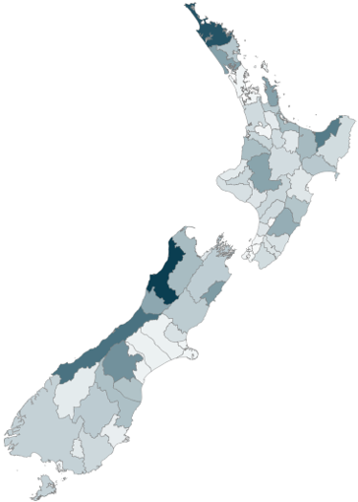
These figures are all indicating upwards trends in people living without shelter and related reports from the public (underlined).
Figures from Auckland Council's latest quarterly update shows that as at the end of May 2025, the 6 providers with outreach capacity were working with 809 unsheltered clients who were sleeping in cars, streets and local parks, up from 653 in January this year, and 426 in September 2024.
Tauranga City Council call centre data shows they had 619 homelessness-related reports from the general public in 2024, up from 423 in 2023. From January to mid-April this year there have been over 250 reports.
PARS Taranaki’s 6-monthly snapshot of clients showed they had an increase in those living without shelter from 10 in June up to 35 in December.
Taranaki Retreat have estimated the current number of rough sleepers in New Plymouth is 30 to 35 individuals.
Porirua City Council initiated quarterly Point in Time Audits for rough sleepers from June 2024 with a total of four audits conducted to up to March 2025. These audits have reported 7, 11, 13, and 18 rough sleepers respectively.
Map shading presents 2023 Census estimates of living without shelter per 10,000 population, darker shades mean higher rates
Whangārei District Council has seen an increase in the number of public reports related to homelessness from 680 in 2023 to 1066 in 2024, at the current rate, they’re forecast to reach over 1,200 reports in 2025. They have a current rate of 32.8 percent of activities associated with homelessness involving antisocial behaviour in the first four months of 2025, up from 29.6 percent in 2024.
Wellington City Council averaged 28 public reports of homelessness per month for 2023, this average was 42 for 2024 and currently sits at 37 for January to March 2025.
Downtown Community Ministry (DCM) in Wellington detailed that for the January to March 2025 period, 328 people were recorded as homeless, a five percent increase on the same period a year prior (312 people). Of these 141 people were recorded as rough sleeping for January to March 2025, a 24 percent increase on the same period a year prior (114 people).
Christchurch City Mission – outreach workers engaged with 270 new clients in the 6 months to the end of March 2025, up from 156 in the prior 6 months.
Limited data from other parts of the sector show:
- As at the end of March 2025, the Department of Corrections estimate at least 350 people were serving post-release orders with no fixed abode.
- An upwards trend in patients presenting at hospital emergency departments for whom no address was recorded from 34 in the month of November 2023 to 64 in the month of November 2024.

Ministry-funded outreach services
For the outreach clients we have the information for from September 2023 to March 2025:
- over half the client households (55.6 percent, about 300 client households) were living without shelter when they were initially engaged, a further 8.0 percent were living in temporary accommodation, 18.5 percent were sharing someone else’s private dwelling and 17.9 percent were in another situation, such as overcrowded housing or insecure tenure.
- the most common reason for clients being homeless was a family or relationship breakdown (30.5 percent). Other reasons include loss of employment or income (11.1 percent), legal issues or incarceration (9.1 percent), mental health and addiction (6.6 percent), domestic abuse (4.7 percent), and being previously homeless (2.7 percent), other housing related reasons made up 18.7 percent.

Specialist mental health and addictions
Preliminary data about specialist mental health and addictions from Te Whatu Ora describing quarterly accommodation check-ins with clients indicates:
- Comparing the October to December quarter in 2024 with 2023, there was a 10.1 percent increase in clients who were homeless (1,915 to 2,109), a 4.9 percent increase for those in supported accommodation (4,750 to 4,984) and a 7.8 percent increase for those living independently (28,898 to 31,139).
- For most months from June to December 2024, there was an increase in the number of people receiving mental health and addiction services who were homeless, when compared with 2023 (see figure 1 below).
- There were 660 people receiving mental health and addiction services who were homeless in December 2024, up from 572 in December 2023. These included 326 Māori in December 2024, up from 255 a year earlier.
- An increase was also evident in the number of nights spent in mental health and addiction facilities for people reported as homeless from July to December 2024 when compared with the same period in 2023. In December 2024 there were 954 total nights stayed by those reported as homeless, up from 669 nights in December 2023.
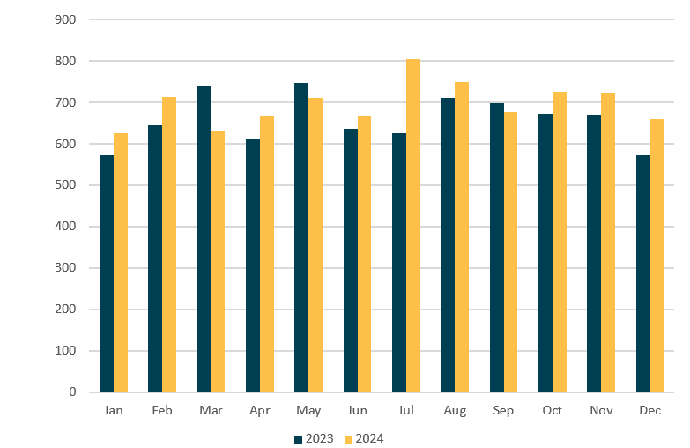
Figure 1: People receiving mental health and addiction services who reported ‘homeless’ as their Supplementary Consumer Record Accommodation status, collected 1 January 2023–31 December 2024

Rangatahi supported through Oranga Tamariki
Oranga Tamariki analysis of narrative reports from December 2024 noted young people leaving care or custody were finding it increasingly difficult to access emergency accommodation. However, they also raised safety concerns regarding emergency housing, that it is oversubscribed, under-resourced and predominantly established to support adult clients.
Reports highlighted the difficulties rangatahi face moving on to more permanent accommodation due to challenges accessing public and private rentals, including:
- affordability
- extra challenges with signing a tenancy agreement under the age of 18
- not being prioritised for public housing, high wait times to access Kāinga Ora homes
- limited options for rangatahi with bail conditions
- not being able to access accommodation due to substance use but not being able to access support programmes without a fixed abode.

2023 Census Severe Housing Deprivation estimates show that 15- to 29-year-olds are more likely than other age groups to be living in temporary accommodation or sharing someone else’s private dwelling.

Emergency housing
Emergency housing is a last resort and only used when there is a genuine, immediate housing need.
Across March 2025, 32 percent of applications for emergency housing were declined (up from 4 percent in March 2024, see figure 2). The leading reasons that people were declined an emergency housing grant were: ‘The need can be met another way’ (34.3 percent), ‘Circumstances could have been reasonably foreseen’ (22.5 percent, this includes where the household is determined to have contributed to their emergency housing need), ‘Not eligible for a grant’ (16.7 percent) and ‘Not an emergency situation’ (14.7 percent).
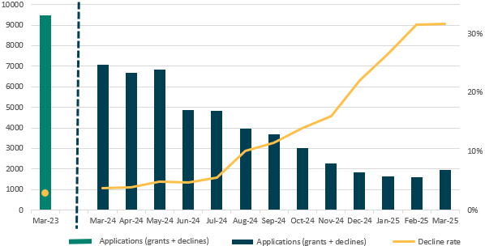
Figure 2: Total emergency housing grant applications and percentage of applications declined, by month
Where people are declined emergency housing assistance, MSD may provide other options, such as a referral to Transitional Housing, or Housing Support Products that provide financial assistance, including rent and bond support to help people access and sustain suitable accommodation.
With Māori making up 60 percent of emergency housing clients, the number of households with a Māori primary client granted emergency housing was approximately 380 client households granted to 260 client households declined (a ratio of 1.46, compared to 1.06 for all applicants). This indicates that Māori households may be slightly more likely to have an immediate housing need that meets the eligibility for emergency housing.
There were 60 Pacific peoples’ households in emergency housing in March 2025, while 75 Pacific peoples’ households were declined emergency housing (a ratio of 0.80).
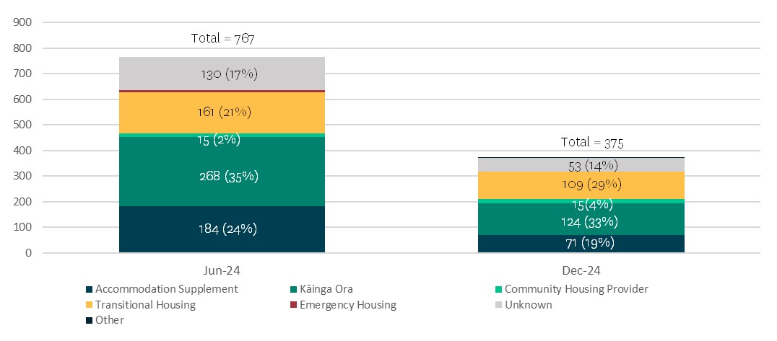
Figure 3: Numbers and proportions of people who access housing services after exiting emergency housing (up to 60 days)
Analysis of data for 60 days following a household exiting emergency housing, shows that from June to December 2024, there was an increase in the proportion of households entering transitional housing (from 21 percent to 29 percent), a decrease in the proportion accessing an accommodation supplement (24 percent to 19 percent) and the proportion going into social housing remained the same (37 percent, see figure 3). The proportion for whom their housing situation remains unknown reduced to 14 percent.

Average length of time spent in emergency housing is about six months, the same as it was a year ago.
About three-fifths of households in emergency housing are there for the first time, this is gradually increasing.

Transitional housing
From April 2024 to March 2025 transitional housing has seen:
- a decreasing trend in the percentage of households whose primary reason for entering transitional housing was that they were living in temporary accommodation (from 35.9 percent to 27.5 percent), this is likely due to fewer people entering from emergency housing (Figure 4).
- a steady increase in single adult households (to 2,201) and a decrease in single parent households (to 1,674), resulting in a slight decrease in the total number of people in transitional housing nationally (from 11,735 in April 2024 to 11,565 in March 2025)
- 60.2 percent of households who exited transitional housing in February 2025, exited into long-term accommodation, while 9.1 percent moved in with family/whānau and 11.5 percent were removed by their provider.
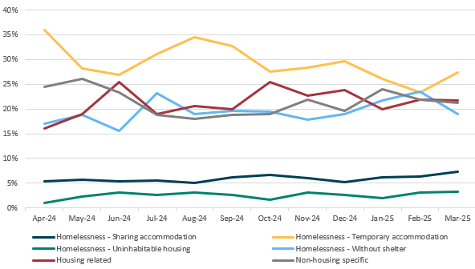
Figure 4: Percentage of households entering transitional housing, by reason, April 2024 to March 2025

Housing register
From March 2024 to March 2025 the social housing register decreased by nearly a quarter.
There have been slight decreases in the numbers of households living in private housing (including boarding, private rentals and own home – from 16,187 to 14,506), sharing someone else’s private dwelling (2,451 to 2,149) and living without shelter (2,508 to 2,261, see figure 5). However, the number living in temporary accommodation has nearly halved (9,045 to 4,598). This means the proportions of households by living situation has shifted, with those in temporary accommodation making up just under a fifth (19.2 percent), while those in private accommodation made up three-fifths (60.7 percent) in March 2025.
There were 9,554 households with children on the social housing register in March 2025, down from 13,563 in March 2024. The priority one fast track means 972 of these households who were previously in emergency housing have been housed since May 2024, including 2,055 children.
The largest decreases in total numbers of households were seen in Auckland (2,042 fewer households), Waikato (874 households), Bay of Plenty (677 households), and Canterbury and East Coast (660 households each). The steepest decreases were seen in Waikato (29.3 percent), East Coast (26.4 percent), Bay of Plenty (25.0 percent) and Central (24.6 percent).

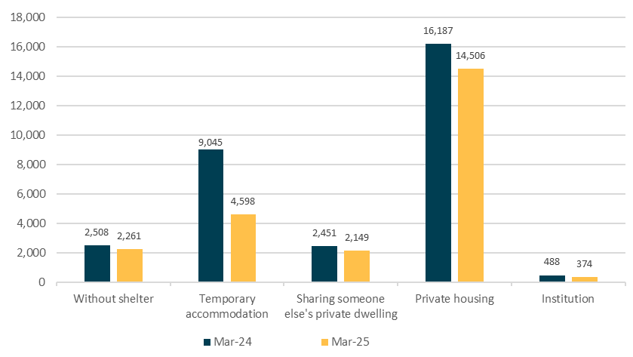
Figure 5: Number of primary applicants on the social housing register by living situation at the time of entry (or latest update)

Housing First – waiting to be housed
Housing First supports people living without shelter, with high or complex needs, to access and maintain stable housing and address trauma and other challenges.
As at the end of March 2025 there were 985 Housing First clients waiting to be housed. These clients receive support from providers as efforts are made to secure the right dwelling to meet their needs. Including time prior to entering the programme, around three in ten Housing First clients waiting to be housed have been homeless for 1-to-2 years (32.4 percent of those in Auckland, and 27.6 percent of those in other areas), with close to 4 in 10 Housing First Clients waiting to be housed having experienced homelessness for 3 years or more (37.8 percent).
- 30.8 percent have experienced four or more episodes of homelessness.
- As at the end of March 2025 there were 49 households where the primary client was 65 years or older.
- Nearly 70 percent (68.7 percent) of Housing First households waiting to be housed outside of Auckland have a primary client who is Māori. In Auckland nearly half the Housing First households waiting to be housed have a primary client who is Māori, while over a quarter (26.7 percent) are Pacific peoples.

Broader system insights that may be affecting homelessness

Lack of employment
Lack of employment can add to household and relationship stress. We are currently seeing reduced numbers of people in paid employment, alongside rising unemployment (5.1 percent in March 2025, up from 4.4 percent in March 2024).
Unemployment rate | Stats NZ

Population growth
Population growth can put pressure on our housing supply. In October 2023, net migration reached a peak (135,529 people) greater than the previous peak of March 2020 (91,680). Since then, net migration has steadily decreased (26,349 in March 2025, Stats NZ).
Net migration eases to under 30,000 | Stats NZ

Rental inflation
Rental inflation reduced to 1.0 percent in November 2024 after it peaked at 7.2 percent in September 2023 (Stats NZ). While this largely aligned with strong wage growth, affordability worsened for those who lost income or did not benefit from average wage increases. For these people, the cost of securing 6 weeks rent (4 weeks bond and 2 weeks rent in advance) may be prohibitive.
Selected price indexes November 2024 | Stats NZ

Availability of appropriate housing
Availability of appropriate housing, such as for one-bedroom units, which dominate the Housing Register, as well as housing for those needing accessible homes and intergenerational families requiring larger dwellings.

Residential construction
Residential construction provides greater supply, this has fallen from its peak but has remained steady since late 2024 with 33,600 consented dwellings in 2024 (Stats NZ). This is still above pre-COVID levels.
Building consents issued March 2025 | Stats NZ

Family violence
Family violence can lead to people needing to urgently seek safety elsewhere. In 2024, 2.3 percent of people in permanent private dwellings were victims of family offences, an estimated 101,000 people. This is not statistically significantly different from the 1.6 percent in 2023 (70,000) people.
New Zealand Crime and Victims Survey

Alcohol, drugs and other substances
Alcohol, drugs and other substance addiction and abuse can be a barrier to accessing and sustaining a tenancy. Of particular note, the latest New Zealand wastewater analysis showed an unprecedented 96 percent increase in methamphetamine consumption in 2024 (1434kg nationally) when compared with 2023 (732kg), with consumption increasing across all sites.
Wastewater 2024 annual overview | NZ Police

How the system is responding to homelessness
Increases in homelessness at any time are a concern, particularly when people are living without shelter, and we acknowledge the impact of this. We have programmes and services in place which aim to prevent this occurring, and to support people when this does happen.
We need appropriate and affordable housing, but as homelessness is driven by structural and system failures (for example, poverty, undersupply, and access to employment, health care and other services) and is triggered by a range of circumstances (eg, family breakdown, loss of employment or income, discrimination and intensifying health conditions) there are other needs that must also be addressed.
The Going for Housing Growth programme will bring about system level change by increasing housing supply and putting downward pressure on housing costs. This will take time and there will continue to be a need for government to support people experiencing or at risk of homelessness.
Social housing of the right type, in the right place – matched to housing need – provides safe and secure housing for people who can’t afford or access private rental housing. We are focused on social housing being provided in the places and to the people that need it most through our new investment approach and the review of the social housing system.
Amongst other things, Budget 2025 creates a new flexible fund for between 650 and 900 social housing and affordable social rentals for delivery from 2027 and commits new funding for up to 550 social homes in Auckland in 2025/26. Kāinga Ora has around 2,650 places under construction for delivery in the next two years, and Budget 2024 provided funding for community housing providers for a further 1,500 places. Since the end of 2023 nearly 1,000 affordable rental homes are planned for delivery by Māori housing providers.
Significant investment has been made in programmes and services which directly prevent and respond to homelessness. In 2024/25 and 2025/26 over $550 million in funding through Vote Housing and Urban Development has been targeted to programmes including outreach, transitional housing, sustaining tenancies, housing first, and rangatahi supported accommodation. Budget 2025 also confirmed $100m over four years to relieve cost pressures for ongoing social housing for households supported by the Housing First and Rapid Rehousing programmes.
We are focused on ensuring these programmes and services are targeted appropriately and are effective in providing the right housing support at the right time to respond to and prevent homelessness. We are also working across Government to prevent homelessness before it occurs, identifying opportunities for early intervention.
MSD’s needs assessments determine eligibility for employment, income and housing support, such as emergency housing grants, housing navigators, ready to rent courses, housing brokers, and financial assistance to help secure or maintain stable accommodation.

Research and reports of interest
Denied: The growing cost of denying young people access to shelter
This report was released by Kick Back, Auckland Action Against Poverty and Action Station. A collation of case studies and quotes from young people (supported by Kick Back) describing the barriers they have faced accessing emergency housing through MSD.
Counting Ourselves: Findings from the 2022 Aotearoa New Zealand Trans & Non-binary Health Survey
Published in late February 2025, this report includes questions exploring trans and non-binary experiences of homelessness and emergency housing.
The Salvation Army provided a briefing for ministers with a summary of observations and data from non-government organisations working with people experiencing homelessness and the barriers they’ve faced accessing services.
The impact of transitions from emergency housing to public housing in Aotearoa New Zealand
A journal article authored by researchers at He Kāinga Oranga Housing and Health Research Programme, University of Otago, Wellington. This analyses the transition from emergency housing to public housing among individuals experiencing homelessness in Aotearoa New Zealand.
The truth behind New Zealand’s housing crisis
Released by the Auckland Housing First Collective summarises 50 OIA requests to local government and central government agencies describing data related to homelessness.
Kathie Irwin and Associates have been contracted by the Coalition to End Women’s Homelessness to develop a Gender Analysis Tool from a te ao Māori lens. This will include:
- analysis of research in the area, including any gaps
- conceptual frameworks
- recommendations for use.

The actual number may be higher, as undercounting is likely to affect all categories of severe housing deprivation.
Regarding exits from emergency housing: 1) One percent of those who exited in December 2024 were classified ‘Other’, which includes those who have left Aotearoa New Zealand or are deceased (figure 3); 2) the ‘unknown’ category includes those who may now be experiencing homelessness and those who may have gone on to other suitable housing options; 3) this is a monthly figure that looks at spells ended across the month.
Ibid, page 2
We appreciate that there are high 2023 estimates of those living without shelter in the West Coast of the South Island. We are reaching out to the sector to better understand this.
Auckland Council’s providers note that their numbers are under-reported as many homeless people are in cars, transient or hidden from sight.
Caution is required when drawing conclusions about homelessness from service data (for example, emergency housing grants, housing register, transitional housing data, provider data). Service data is sensitive to operational and administrative changes (such as changes to management of the housing register) and reflects the number of people accessing a service. Service data does not measure the number of people experiencing homelessness.
Data from Te Whatu Ora is not a reflection of actual levels of homelessness of people accessing health services, rather the information that can be identified via the National Collections.
Oranga Tamariki. (2025). Oranga Tamariki Transition Support Services insight document: Thematic trends from Transition to Adulthood and Supported Accommodation returns relevant to housing for Transitions Young People. [Unpublished].
Ibid, page 8
The system used to administer emergency housing grants is the system used for all hardship grants administered by MSD. While specific emergency housing grant decline reasons have been added to the system, staff can also select other reasons which may be more relevant to other hardship types. There is also a possibility for human error (for example, clicking the wrong reason).
An emergency housing grant decline represents an application that has been processed and considered ineligible. The number of declines should not be considered representative of unmet demand for services, as we do not know the level of need that does not progress to a processed application (figure 2). A household may be granted emergency housing and declined emergency housing in the same month.
Ethnicity comparisons are based on primary client rather than household data. There could be a household of Pacific peoples, but if the primary applicant identifies as Māori that will be recorded.
Ibid, page 10.
Regarding exits from emergency housing: 1) One percent of those who exited in December 2024 were classified ‘Other’, which includes those who have left Aotearoa New Zealand or are deceased (figure 3); 2) the ‘unknown’ category includes those who may now be experiencing homelessness and those who may have gone on to other suitable housing options; 3) this is a monthly figure that looks at spells ended across the month.
Ibid, page 8.
Ibid, page 11.
When a household enters the register, MSD staff select the client’s living situation from 22 options. For simplicity, this report has used the Stats NZ homelessness definition to create higher-level categories where possible (without shelter, temporary accommodation, sharing someone else’s private dwelling, private housing). Private dwelling is mostly made up of those who are renting or boarding. There may be some error due to variation in how MSD staff assign accommodation type (figure 5).
Ibid, page10.

