

Homelessness insights

To 30 September 2025

How to find your way around this report
This report brings together a wide range of data and insights about homelessness in New Zealand, with a focus on people living without shelter. Here’s how to get the most out of it.
Key points
Start here for the overarching interpretation of the data and observations. (page 3)
Government support
A description of some of the programmes and initiatives funded, planned or underway that contribute to addressing homelessness. (pages 4 to 5)
Government-held data  Area breakdowns of 2023 Census living without shelter estimates: Analysis of the 2023 Census, highlighting the five areas with the highest estimated counts of people living without shelter, broken down by children, older people, females, Māori and Pacific peoples.  (pages 8 to 9)  Housing-related service-use data: Data from Te Tūāpapa Kura Kāinga – Ministry of Housing and Urban Development and the Ministry of Social Development, including outreach services, housing first, emergency and transitional housing, and the social housing register.  (pages 9 to 13)  Support when leaving state care: This section includes short summaries of data available from the Department of Corrections and Oranga Tamariki.  (page 14)  Provisional figures from Health New Zealand – Te Whatu Ora: Insights from the health system including hospitalisations and emergency department visits, and accommodation check-ins with people using specialist mental health and addiction services.  (pages 14 to 16) |  | Council and provider data  Figures from around the country: Recent local figures that show whether there might be people living without shelter in that area and whether the numbers might be increasing or decreasing.  (pages 5 to 8)  Observations from around the country: Themes and context drawn from group sessions with council staff and non-government organisations who work with young people, as well as sector insights.  (pages 16 to 17)  Finding refuge: Short summaries of data available from refuge providers.  (page 18)
The Broader system and research
Broader system insights that may be affecting homelessness: Some data from the broader system that can impact on homelessness, including employment, migration and rental trends.
(pages 18 to 19)
Research and reports of interest: A selection of recent research and reports for further reading.
(page 20)

Introduction
This report shares insights on homelessness using data and observations. It mainly focuses on people living without shelter but also includes information on other types of homelessness where possible. Most data is current to September 2025, though some sources have delays.
Homelessness is defined as living situations where people with no other options to acquire safe and secure housing are without shelter, in temporary accommodation, sharing accommodation with a household or living in uninhabitable housing.,
The most robust estimates of homelessness are severe housing deprivation estimates from the five-yearly Census.13 These suggest there were at least 112,500 people (of whom at least 34,560 were Māori) who were severely housing deprived on 7 March 2023, including 4,965 people (1,308 Māori) estimated to be living without shelter.13

Living situations that provide no shelter, or makeshift shelter, are considered as ‘without shelter’.1 These include situations such as living on the street and inhabiting improvised dwellings (for example, living in a garage, a shack or a car).
Te Tūāpapa Kura Kāinga – Ministry of Housing and Urban Development is collaborating with Stats NZ, councils and providers to improve access to timely, consistent homelessness data. While this work progresses, this report draws on multiple different types and sources of data to identify potential trends and drivers of these.

Things to remember as you read this report
- Pay attention to the dates and time periods covered by each data source – they’re not always the same.
- Check the description of the figures you’re looking at, for example, these might be households, people, bed nights or reports from the public.
- For local insights, use the area breakdowns and provider insights to add context.
- Check the footnotes and links provided for more detail on definitions or data sources.

Key points
The Government’s Going for Housing Growth programme means it’s focused on addressing the housing market by freeing up land, removing planning barriers, improving infrastructure funding and incentivising councils to support housing growth.
Alongside this, the Government continues to invest in homelessness programmes, with recent actions focused on helping people who are rough sleeping into homes. Significant social and affordable housing delivery is underway through community housing providers, Kāinga Ora and Māori housing providers.
A new housing investment plan focused on those in high need, has identified areas including the Far North District for targeted investment of social housing and affordable rentals.

- Homelessness, particularly the numbers of people living without shelter, remains a challenge across the country. Some areas have continued to see an increase in people living without shelter, while for other areas this may have stabilised or decreased a little. Localised population needs are why provider-led responses are important.
- The number of people living without shelter can change with the seasons. This report mostly uses data up to September, which covers autumn and winter. The previous report used data up to March, reflecting spring and summer.
- Homelessness affects many different parts of the population. The data in this report highlights that, in addition to adult males, homelessness affects children, young people, older people, females, Māori and Pacific peoples.
- Māori are particularly overrepresented among those living without shelter.
- Data indicates a high level of need in the Far North District, consistent with findings from the 2023 Census living without shelter estimates.
- Homelessness happens for many overlapping reasons. Providers have noted the increasing complexity of these, including addiction, mental health issues, domestic violence, trauma and financial stress.
- Aside from an increase in unemployment, drivers such as population growth and rental inflation appear to be easing, which may soften some of the barriers people face trying to access stable housing.
- It is not possible to tell whether changes described in this report reflect existing trends and broader economic and social contexts or are attributable to policy changes, including the immediate actions announced in September 2025.

Government support
Increases in homelessness at any time are a concern, particularly when people are living without shelter. Government has programmes and services in place which aim to prevent this happening and to support people when it does.
The figure below shows investment of over $550 million through Vote Housing and Urban Development targeted to programmes including Housing First, transitional housing, sustaining tenancies and rangatahi supported accommodation. The figure also includes over $230 million in funding through Vote Social Development for emergency housing grants and housing support products (Ministry of Social Development (MSD)).
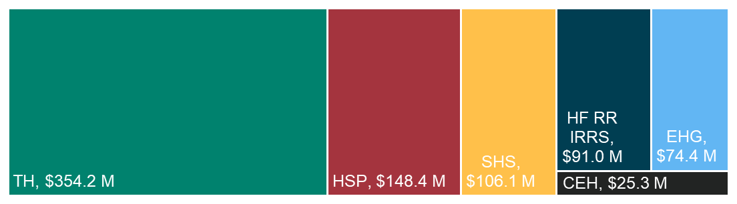
TH | Transitional housing
HSP | Housing support products (financial assistance, for example, moving costs, bond payments, rent payments in advance) – MSD
SHS | Social housing services (housing and support programmes, for example, Housing First, sustaining tenancies, rangatahi supported accommodation)
HF RR IRRS | Housing First and Rapid Rehousing income-related rent subsidy social housing places
EHG | Emergency housing grants – MSD
CEH | Contracted emergency housing (Rotorua only)
Figure 11: Annual Ministry and MSD spend on homelessness-related programmes and assistance in the year to 30 June 2025
In September 2025, the Government announced five immediate actions to expand the support for people who are rough sleeping and help them into homes in Auckland, Wellington, Hamilton and Christchurch. This included $10.8–11.6m per annum for 300 additional income-related rent subsidy social housing places for people in the Housing First programme and rough sleeping, as well as a $10m investment for locally led initiatives in those centres developed by providers supporting people who are sleeping rough (flexing current contracts).
As part of the immediate actions, the Ministry is working with providers to increase occupancy in transitional housing, for example, reducing the time between stays in transitional housing (between one household going out and the next household coming in). MSD has expanded guidance for its staff on using discretion to assess applications for emergency housing grants and is proactively connecting with local homelessness outreach services to identify and support people without shelter to access MSD services and products.
In Auckland (as in other centres) local and central government agencies work together to make support available at the right times and in the right places for people who are sleeping rough. Medium to longer term work by ministers is underway including reviewing housing and support programmes to make the system response simpler, more effective and less duplicative, and work to better support people leaving residential support programmes or prison. Ministers are also looking at ways to improve the social housing system to deliver the right homes, in the right places, for the right people.
Social housing of the right type, in the right place – matched to housing need – provides safe and secure housing for people who can’t afford or access private rental housing. We are focused on social housing being provided in the places and to the people that need it most through our new investment approach.
Budget 2024 provided funding for 1,500 new social housing places to be delivered by community housing providers by 2027. Budget 2025 enabled a new flexible fund and provided funding for between 675 and 770 new social homes and affordable rentals for delivery from 2027. Budget 2025 also committed new funding for up to 550 social homes in Auckland in 2026. Kāinga Ora has around 2,650 places under construction for delivery in the next two years. Since the end of 2023 nearly 1,000 affordable rental homes are planned for delivery by Māori housing providers.
The Government’s housing investment plan sets out a new approach to better target investment in housing. Using data and insights from communities, the Far North District, South Auckland, Eastern Bay of Plenty (Whakatane, Kawerau, and Ōpōtiki), Tairāwhiti-Gisborne and Hastings have been identified for targeted investment of social housing and affordable rentals, alongside further investment in main centres (Hamilton, Tauranga, Wellington and Christchurch).
The long-term focus for government is on fixing the fundamentals of the housing market: freeing up land, removing planning barriers, improving infrastructure funding and giving councils stronger incentives to support housing growth, increasing the availability of appropriate and affordable housing.

Living without shelter figures from around the country
Data is available from more areas around the country and it’s clear that people living without shelter is a challenge for both small and large towns.
Data in the following section is not standardised so care needs to be taken when interpreting results. Changes in the number of people living without shelter in an area can only be assessed when comparable data from two time periods is available.
Table 1: Legend for table 4 describing the different types of data included
Code | Type | Description
C | Count | A count undertaken in a consistent manner of specific areas.
L | List | The number of people on a list maintained through local relationships and knowledge of people living without shelter.
O | Outreach | The number of people service providers have met and engaged with.
S | Service use | The number of people who have accessed a particular service that targets people who are likely to be living without shelter.
Code | Change | Description
• | No change | There is not enough data to determine whether the number of people living without shelter is likely to have increased, decreased or stayed the same.
 | Increase | The data provided indicates that there may have been an increase in the number of people living without shelter.
↓ | Decrease | The data provided indicates that there may have been a decrease in the number of people living without shelter.

Table 2: Figures sourced from around the country that provide a description of the extent, or any change in the trend of people living without shelter
Area (change | type) | Description
Auckland  ( | O) | Auckland Council's quarterly update shows that on 30 September 2025, six outreach providers had engaged with 940 people who were known to be sleeping in cars, streets and local parks, up from 809 on 30 May this year and 426 on 30 September 2024.
Thames  ( | L) | Thames-Coromandel District Council and partners estimate that at the end of September 2025 there were around 25 people who regularly sleep rough in central Thames. This excludes people who stay for shorter periods before moving on to other areas.
Hamilton  ( | C) | In Hamilton the People's Project undertake a Connections Week in the middle of each year to offer support to people. In July 2025 they met 92 people, 27 were rough sleeping and 65 were in cars. This is up from 69 in 2024 when 22 were sleeping rough and 47 were sleeping in cars.
Whakatāne  (• | C, L) | Whakatāne District Council and partners took a snapshot of people they were working with, alongside a count on 21 October. This found 45 people who were sleeping rough and another 25 people sleeping in cars in Whakatāne and Ōhope townships. The Council notes there are also people experiencing homelessness in other townships across the district.
Gisborne  (• | L) | Gisborne’s men-only shelter usually supports 32 men each night, while any female partners often sleep rough. By mid-September 2025, the shelter knew of 40 people either staying there or sleeping rough in the city centre.
New Plymouth  (• | S) | In New Plymouth 97 unhoused homeless people used the YMCA day services from mid-April to the end of September. YMCA opened a night shelter in early October 2025.
Masterton  (• | S) | In Masterton, Kim’s Way night refuge opened on 24 June 2025. Since then, they’ve had 6 regular guests and have provided shelter to 18 people in total between 24 June and 30 September.  Shelter Masterton Inc runs a volunteer-led day centre offering food, drink, laundry and showers; they have had a constant demand of 10 to 20 people at a time over the past 4 years.
Palmerston North  (• | O) | A Palmerston North City Council-funded outreach programme began operating in March 2025. From 1 July to 7 October the programme has engaged with 68 people, housing 18. This is from a total of 143 people living without shelter who the team have engaged with since March; 84 have been supported into housing.
Porirua  (↓ | C) | Porirua City Council's quarterly count reported 11 people who were rough sleeping in early September 2025, the same number as reported for September 2024, and down from 14 in June 2025.
Wellington  (↓ | O) | In Wellington, Downtown Community Ministry (DCM) recorded 313 people as homeless between July and September 2025, a 9 percent decrease compared to the same period in 2024, when there were 345. Of these, 131 were rough sleeping, which is a 4 percent decrease from the 137 recorded in the same period the year before.
Christchurch  ( | O) | Christchurch City Mission outreach workers connected with 214 new clients between March and August 2025. That’s an increase from the same period in 2024, when they worked with 156 new clients.

Council reports from the public
Some councils have systems that allow reports from the public to be coded when they’re specifically about homelessness. Councils may receive multiple reports about a single case of rough sleeping, so this data does not tell us how many people are sleeping rough, however, it can indicate that there are people in this area who may need support and whether it’s likely this number of people has changed over time.
- Whangārei District Council collects reports about homelessness through its CitySafe system – 680 in 2023, 1,066 in 2024 and 805 so far in 2025 (as of the end of September).
- In the 12 months to 30 September 2025, Thames-Coromandel District Council received 72 reports from the public about people who were sleeping rough, 44 of these were from Thames. This compares with 46 total reports received in the year to 30 September 2024, including 33 from Thames.
- Tauranga City Council had 553 homelessness-related reports from the public from January to the end of September 2025, compared to 449 reports for the same period in 2024.
- Rotorua Lakes Council’s Safe City Guardians recorded 445 homelessness related callouts in the inner city from July to September 2025; this compares with 398 callouts from April to June 2025 and 194 for July to September 2024.
- Wellington City Council had 393 homelessness-related reports from the public from 1 April to 30 September 2025, this compared to 274 reports for the same period in 2024.

Area breakdowns of 2023 Census living without shelter estimates
We have done further analysis on the 2023 Census results to provide additional insights by area for people living without shelter.
The estimate of people living without shelter is measured as either:
- living as a roofless or rough sleeper with no other address
- living in an improvised or mobile dwelling with no other address and a low dwelling income (under $43,000 equivalised).
The areas with the highest counts of people living without shelter across the country were the Far North District (525), Whangarei District (237), Christchurch City (171), Western Bay of Plenty District (168) and Tasman District (165).13
Analysis, of the 2023 severe housing deprivation estimates by territorial authority and Auckland local board area shows the Far North District was the area with the highest estimated number of females, children, older people and Māori living without shelter.
Table 3: Five areas with the highest 2023 Census estimated counts (in brackets) of people living without shelter for children, older people, females, Māori or Pacific peoples
Under 15-year-olds | 65 years and over | Females | Māori | Pacific peoples
Far North District (102) | Far North District (117) | Far North District (243) | Far North District (252) | Māngere-Ōtāhuhu Local Board Area (39)
Western Bay of Plenty District (30) | Whangarei District (75) | Whangarei District (96) | Whakatane District (69) | Far North District and Manurewa Local Board Area (30 each)
Whangarei, Whakatāne and Waikato districts (27 each) | Western Bay of Plenty District (45) | Western Bay of Plenty District (78) | Western Bay of Plenty District (63) | Papakura Local Board Area (21)
 | Kaipara District (42) | Tasman and Waikato districts (66 each) | Gisborne District (51) | Ōtara-Papatoetoe Local Board Area (18)
 | Tasman District (39) |  | Whangarei District (48)

Housing-related service use data

Ministry of Housing and Urban Development-funded outreach services
Homelessness outreach services aim to support people experiencing homelessness, particularly people who are sleeping rough or sleeping in other uninhabitable places. They work to remove barriers and connect people to housing, health care and other basic needs so they can move out of homelessness.
At the end of September 2025, nine providers (funded by Te Tūāpapa Kura Kāinga – Ministry of Housing and Urban Development) were actively working with 582 outreach households. Of the 411 we have information for, nearly two thirds (65.5 percent) were living without shelter when first contacted. About 5 percent were in temporary housing, nearly 15 percent were staying in someone else’s private home, and another 15 percent were in other situations like overcrowded or unstable housing.
Homelessness is often the result of multiple, overlapping reasons. We analysed the reasons for homelessness reported by nearly 300 client households:
- Family or relationship breakdown was reported by nearly half the households (45.0 percent).
- Loss of employment or income affected 31.9 percent, while housing affordability challenges were mentioned by 29.2 percent.
- Eviction was a factor for one in four households (24.5 percent).
- Just over 1 in 10 households identified issues such as substance abuse or addiction (13.1 percent), mental health challenges (12.1 percent), legal issues or incarceration (11.4 percent) or lack of social support (10.4 percent).
- Domestic abuse was reported by 8.4 percent of households.

Housing First – not yet in stable housing
The Housing First programme provides support for people experiencing chronic homelessness with high or complex support needs to access stable housing, address trauma and other challenges, and prevent a return to homelessness. Support is ongoing and focuses on maintaining a tenancy. People in the programme who are not yet housed may be living in a variety of situations including with others, in temporary accommodation, or living without shelter. It can take time to build rapport with clients. When someone has been homeless for some time it can also take time for them to be comfortable interacting with services.
At the end of September 2025, 1,066 households in the Housing First programme were not yet in a stable home. These people get support from service providers who are working to find the right kind of housing for them and address other challenges.
The greatest challenge in housing people appears to be in the Far North District where 50 percent (51 households) of those not yet housed at the end of September have been in the programme for two to three years. Rotorua District also presents a challenge with over a third (35.9 percent, 66 households) of those not yet housed having been in the programme for upwards of three years.
Looking at who the primary householder is for those in the programme who are not yet housed at the end of September 2025:
- Most are aged between 25 and 54; there were also 73 people under 25, 158 aged 55 to 64 and 61 aged 65 or older.
- In the Far North District, most are women (74 percent). In Rotorua, women and men are equal (50 percent). In other areas, women make up around one-third.
- In the Far North, Whangārei and Rotorua districts, over 85 percent are Māori. In other areas, this ranges from 45 to 67 percent.
- In Auckland, nearly 3 in 10 of the primary householder clients are Pacific peoples.

Ministry of Social Development emergency housing grants
Emergency housing grants are a last resort and only used when there is a genuine, immediate housing need. Emergency housing grants are available for people who are eligible and need a short-term place to stay. Because these stays are temporary, people often move in and out of emergency housing.
From 1 July to 30 September 2025, a total of 6,304 emergency housing applications were received. Of these, 3,930 (62.3 percent) resulted in grants, while 2,374 (37.7 percent) were declined.
Among applicants, 1,697 (26.9 percent of all applications or 71.5 percent of all declines) received additional assistance such as the accommodation supplement, a housing support product, a referral to transitional housing support, or other hardship assistance within 7 days of a declined application.
Another 677 (10.7 percent of all applications or 28.5 percent of all declines) were declined with no other assistance received or referrals processed within the 7-day period.
MSD can identify whether clients access any housing-related services it holds data on, directly after staying in emergency housing.
Of the number of households that exited emergency housing during June 2025:
- 23 percent of clients moved into social housing (2.5 percent through community housing providers (CHPs) and 20.5 percent through Kāinga Ora)
- 33.5 percent went into transitional housing
- 23 percent received the accommodation supplement for a private rental (this includes clients with mortgage, private rental or board costs)
- 17.6 percent did not access any of these housing-related services.
Note: These figures are based on the primary client receiving a housing-related service within 60 days of exiting emergency housing.

Transitional housing
Transitional housing15 includes temporary housing and supports for people with an immediate housing need who have nowhere else to stay, with a focus on wrap around support for people to move into stable housing such as private rentals and social housing.
As at the end of September 2025 a fifth (19.7 percent) of households entering transitional housing15 did so because they were living without shelter, this was the same proportion as at the end of September 2024.
The make-up of households in transitional housing has changed between September 2024 to September 2025. The number of single-parent households and other families with children steadily declined, to 1,574 (from 1,779) and 742 (from 827) respectively. At the same time, there was an increase in single adult households, which rose to 2,237 (from 2,091) and households made up of couples or multiple adults, which grew to 225 (from 183).
This means that by the end of September 2025, there were 5,309 children in transitional housing, down from 6,176 a year earlier, and the total number of people in transitional housing across the country fell from 12,143 in September 2024 to 11,201 in September 2025.
Due to government commitments to end motel-use and the end of time-limited funding, there has been a decrease in motel-based transitional housing places (mostly single bedrooms and studios) from 740 to 244. A further 92 non-motel-based places have been contracted, resulting in an overall decrease of around 400 places.
From September 2024 to August 2025 between 610 and 725 households entered transitional housing each month. Over the same period between 565 and 769 households left transitional housing each month.
In August 2025, three out of five households leaving transitional housing (62.1 percent) moved into social housing or private rentals. Some were removed by their provider (10.9 percent), moved in with family or whānau (6.5 percent) transferred to other providers (6.1 percent), voluntarily left (5.5 percent), moved into a motel, lodge or boarding house (0.7 percent) or left for some other reason (8.2 percent).
Ethnicity data for the primary household applicants in transitional housing as at the end of June 2025 shows:
- In the Northland, Waikato, Bay of Plenty, East Coast and Taranaki regions over 75 percent were Māori. In other areas, this ranges from 39 to 62 percent.
- In Auckland roughly the same proportion of people were Māori (45 percent) or Pacific peoples (44 percent).

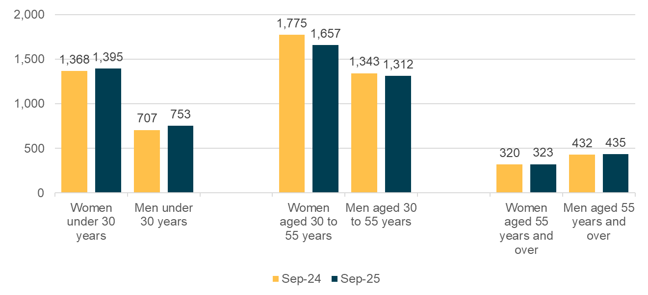
Figure 22: Number of adults in transitional housing by age group and gender, September 2024 and 2025

Social housing register
The social housing register15 is used to prioritise who gets housing. Households are ranked from A to D with those assessed in the A or B categories being eligible for social housing. Housing is offered to households based on the availability of a property to meet their needs.
From September 2024 to September 2025 the social housing register decreased by over 2,500 households.
Between September 2024 and 2025, there were small decreases in the number of households on the register living in private housing (like renting, boarding or owning a home – from 10,953 to 10,422), sharing someone else’s private dwelling (2,247 to 1,995) and living without shelter (2,286 to 2,199, see figure 3). Just over half of applicants (53.6 percent) were in private housing, while around 1 in 10 were either sharing someone else’s home (10.3 percent) or had no shelter (11.3 percent). There was a bigger drop in those living in temporary accommodation from 6,024 to 4,377 households, which was the situation for about 1 in 5 households (22.5 percent) in September 2025.
There were 9,162 households with children on the social housing register in September 2025, down from 11,456 in September 2024. The priority one fast track means 1,086 households who were previously in emergency housing have been housed since May 2024, including 2,328 children.

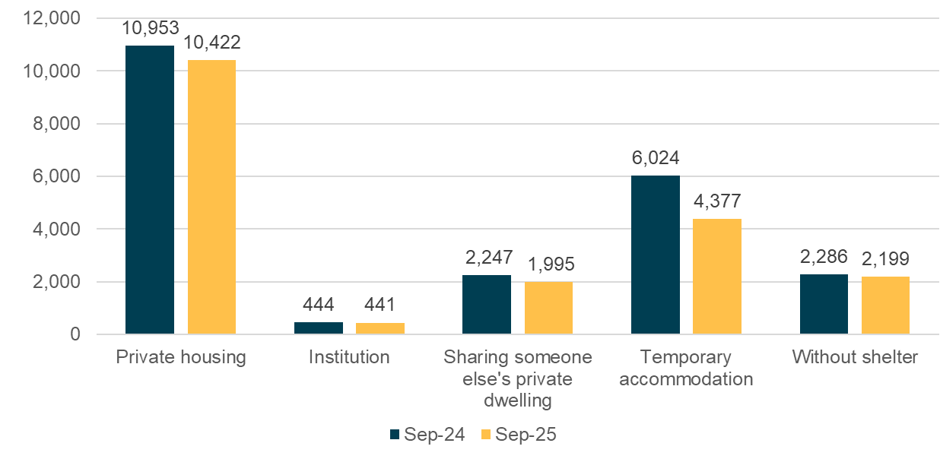
Figure 33: Number of primary applicants on the social housing register by living situation at the time of entry (or latest update)

Support when leaving state care
The Department of Corrections estimated that as at the end of September 2025, just over 400 people across New Zealand were serving post-release orders with no fixed abode. This is a decrease from 500 people in September 2024. As at the end of September 2025 the highest numbers were in the Auckland (86), Bay of Plenty (58) and Canterbury (56) regions.
Oranga Tamariki transition support services are available for 15- to 25-year-olds who have been in care or custody for over 3 months continuously. From April to September 2025 financial assistance was provided to 11 young people who called the Oranga Tamariki transition assistance helpline seeking support for emergency accommodation. Assistance was provided to 8 young people in the same period in 2024.

Provisional figures from Health New Zealand – Te Whatu Ora
The national health index (NHI) is a unique identifier assigned to each person who receives health care in New Zealand. As at 2 October 2025, 4,106 people residing in New Zealand had ‘no fixed abode’ recorded as the first line of their address in the NHI:
- Fifty-one were children aged under 15 years.
- There were 1,095 people aged 65 years or over.
- Nineteen-point-two percent were Māori ethnicity
- Health districts with more than 200 people with no fixed abode included:
  - Auckland (1,015), Counties Manukau (492) and Waitematā (334)
  - Canterbury (450)
  - Bay of Plenty (290)
  - Waikato (250)
  - Capital and Coast (218)
  - Northland (217).

Hospitalisations and emergency department visits
While hospitalisation data fluctuates, provisional data indicates a rising trend in hospitalisations where homelessness19 has been recorded as a diagnosis from late 2023 through to May 2025 (see figure 4 – moving averages can be used to smooth out fluctuations in data). From January to June 2025, there were 949 hospitalisations, up from 880 hospitalisations for the same period in 2024.
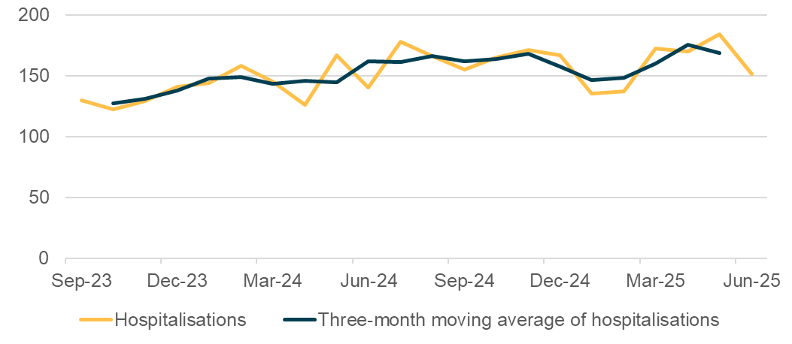
Figure 44: Number and three-month moving average of hospitalisations that included a ‘homeless’ diagnosis code, September 2023 to June 2025
Provisional data from hospital emergency departments19 indicates that the number of presentations without a recorded address peaked in December 2024 at 64. Since then, the numbers have been going down with a provisional count of 38 in June 2025, compared with 39 recorded in June 2024.

Specialist mental health and addictions
Preliminary data from Health New Zealand – Te Whatu Ora on specialist mental health and addiction services shows quarterly updates on clients’ accommodation situations.
- When comparing April to June 2025 with the same period in 2024, the number of clients recorded as homeless decreased by 3.4 percent (1,995 to 1,927); the number in supported accommodation increased by 8.6 percent (4,670 to 5,071) and the number living independently decreased by 3.3 percent (28,798 to 27,852).
- In June 2025, 469 people who were receiving mental health and addiction services were homeless, down from 475 in June 2024. This included 206 Māori in June 2025, compared to 221 the year before.
- From January to June 2025, there was an increase in the number of nights spent in mental health and addiction facilities by people reported as homeless, compared with the same period in 2024. In June 2025, homeless individuals stayed a total of 970 nights, up from 571 nights in June 2024.

Observations from around the country
This section summarises key themes and insights gathered from councils, service providers and community groups across New Zealand, highlighting the diverse experiences and challenges faced in addressing homelessness, including for those living without shelter, at a local level.

Common themes we’ve heard from council staff
We analysed information from group sessions held in early October with Te Kāuru members from 13 different councils across the country. These are the main themes from what we heard:
- Homelessness has increased this winter compared to last and is more visible, especially in seasonal summer hotspots. Growing numbers of young people and women are affected.
- There is a lack of suitable housing and support solutions, especially for disabled people and those with complex needs.
- Staff in some areas felt clearer direction is needed in terms of a mandate to address homelessness.
- More collaboration is sought between non-government organisations, local and central government, especially in smaller areas where limited funding creates competition between services.

Themes from those working in the sector
The National Homelessness Data Project collated insights from people working in the sector. These are the main themes from what they collated:
- Addiction, mental health issues, domestic violence and financial stress are increasingly common causes of homelessness. For women, trauma and violence are predominant drivers.
- There are increasing numbers of people who are sleeping rough including more people experiencing multiple episodes in the past six months, and longer periods of homelessness. The number of rangatahi (young people) experiencing homelessness has increased.
- While some people are entering social housing, overall supply remains well below need. Many are forced to decline shared temporary accommodation due to their support or health needs.

Themes from those who work with young people
We analysed information from group sessions held in late October with ten Manaaki Rangatahi Youth Homelessness Collective members from organisations across the country who work with young people (rangatahi). These are the main themes from what we heard:
- More young people are becoming homeless, often hidden, living in cars, couch-surfing or moving frequently. This includes growing numbers of young families and pregnant mums.
- Issues are complex, including experience of trauma, in some cases this can mean a reliance on prescription or other drugs.
- Even one night homeless is too much; youth-specific urgent care options are needed and young people want to stay in their own communities.
- Call for a national youth homelessness strategy focused on prevention, early help and lasting solutions for young people and their whānau. Investing early to prevent youth homelessness will save money over the long term.
- Manaaki Rangatahi networks are a key strength and resource, connecting communities to find solutions with limited resources.
The highest estimated count of young people aged 15 to 29 years living without shelter from the 2023 Census, was in the Far North District, at least 45. This was followed by Papakura with at least 27. Hastings, Queenstown-Lakes, Tasman and Whangārei each had at least 18 young people living without shelter.12

Finding refuge
Safe houses provide temporary shelter and support for people in crisis. There are a number of organisations that offer safe houses around the country – we have data here from two of them.
Presbyterian Support Northern – Shine runs two safe houses, each with five bedrooms, for people escaping family violence. On average, people stay for two weeks. In the year ending June 2025, they supported 78 adults and 76 children with refuge, an increase from 49 adults and 71 children in the year ending June 2024.
The National Collective of Independent Women’s Refuges is the umbrella organisation for 41 affiliated refuges located throughout New Zealand. In the three months leading up to the end of June 2025, the National Collective of Independent Women’s Refuges supported 2,630 referrals for women and children through their safe houses around the country. They supported 2,283 referrals in the same period in 2024. More than half (56.8 percent in year to end of June 2025) of those supported were wāhine and tamariki Māori. The number of safe house bed nights has decreased from a peak in mid-2024. One reason for this might be Whānau Protect Services, which help women feel safer in their own homes, for example, by installing safety alarms, so they can return home.

Broader system insights that may be affecting homelessness

Employment
Lack of employment can add to household and relationship stress, resulting in housing instability. We are seeing reduced numbers of people in paid employment, alongside rising unemployment (5.3 percent in September 2025, up from 4.9 percent in September 2024). As well as this, in the 3 months to the end of September 2025 there were 132,600 people working part-time who wanted, and were available, to work more hours – 16,200 more people than for the same period in 2024 (116,400). This may indicate people have had their hours reduced or have had to take a part time rather than full time job, likely resulting in a reduction in household incomes.
Labour market statistics: September 2025 quarter | Stats NZ

Population growth
Population growth can put pressure on housing, including rentals. Net migration for the year ended September 2025 was 12,434, this was 42,436 for the year ended September 2024 and 132,723 for the same period in 2023.
International migration: September 2025 | Stats NZ

Rental inflation
Rents for new tenancies have continued to come down since they peaked in September 2023 (7.4 percent). In the year to the end of September 2025, there has been a 0.4 percent decrease in rents nationally. In Auckland this decrease was 0.6 percent and 6.4 percent in Wellington, while rents rose 2.1 percent in Canterbury. This means rents in current tenancies are less likely to be going up.
Annual rental price index update for September | Te Tūāpapa Kura Kāinga – Ministry of Housing and Urban Development

Rent arrears
In the year ending June 2025 landlords used the Tenancy Tribunal to end 18,141 tenancies due to rent arrears, which was 12 percent of all closed bonds over this period. This figure was 17,217 for the year ending June 2024, which was 12.1 percent of all closed bonds.
Data and statistics | Tenancy Services

Residential construction
Residential construction increases the supply of housing. In the year ended September 2025, there were 34,882 new homes consented, the highest number of homes consented in more than two years, up 3.6 percent compared with the year ended September 2024.
Building consents issued: September 2025 | Stats NZ

Mental health
Mental health challenges can make it harder for people to keep stable housing, while insecure housing can make mental health worse. Experience of high or very high levels of psychological distress in the past 4 weeks has increased over the 10 years to 2024/25 (14.3 percent, up from 6.2 percent in 2014/15). This was highest for 15- to 24-year-olds (22.9 percent, up from 7.7 percent), reflecting a generational change in mental health for young people.
New Zealand Health Survey Annual Data Explorer | Ministry of Health

Alcohol, drugs and other substances
Alcohol, drugs and other substance addiction and abuse can be a barrier to accessing and sustaining a tenancy. Based on analysis of wastewater testing, methamphetamine consumption in New Zealand averaged 29.1 kilograms per week across tested sites in the three months to the end of June 2025. This compares with averaging an estimated 18.1 kilograms per week for the same period in 2024.
Wastewater Drug Testing Quarter Two Overview | NZ Police

Research and reports of interest
Here’s a selection of recently released research and reports.
More Than a Home: Tackling the Urgent Youth Homelessness Crisis in Tāmaki Makaurau
Published in April 2025 by Mā Te Huruhuru
This report was prepared by Manaaki Rangatahi Collective and Making Everything Achievable. It describes the kōrero, Post-it notes, reflections and visions from a hui of over 80 organisations, community leaders and taitamariki held in March 2025.
New Data Highlights Urgent Need for A Coordinated Response to Homelessness Across the Nation
Published in July 2025 by The Salvation Army
This is the July 2025 release from the National Homelessness Data Project; the second of a six-monthly survey of housing support providers.
Entry Point Survey Pilot Research Report
Published in June 2025 by the National Homelessness Data Project
This report outlines the methodology, key findings and outcomes from a pilot study involving a brief ten-question survey conducted at the initial client contact point by four service providers across the country.
State of Care Report 2025
Published in October 2025 by VOYCE – Whakarongo Mai
This is the first of a biennial state of care report with information from more than 50 existing submissions and 140 official reports to assess whether six promises laid out in 2020 are being kept for children and young people in care.
Whakarongo Mai! Listen Up! E Tū Tohe Ana Ngā Kaumātua Mō Ngā Take Whare, Seniors Take a Stand on Housing
Published in October 2025 by Toi Āria: Design for Public Good
This work describes the lived experiences of older people in terms of housing and homelessness and the solutions they offer.

Footnotes

Statistics New Zealand. (2015). New Zealand definition of homelessness: update. Retrieved from: https://www.stats.govt.nz/assets/Uploads/Retirement-of-archive-website-project-files/Methods/New-Zealand-definition-of-homelessness/nz-definition-homelessness-2015-update.pdf.
The Waitangi Tribunal found that the Crown breached our treaty duty of consultation through failure to adequately consult with Māori in the development of the homelessness definition in 2009 and through our failure to rectify this in the period since. The Tribunal made one recommendation in its findings from Phase One of the Kaupapa Inquiry into Housing Policy and Services – that the Crown and claimants should work together in partnership to co-design a new definition. Ministry of Justice. (2024). Kāinga Kore: The Stage One Report of the Housing Policy and Services Kaupapa Inquiry on Māori Homelessness. Retrieved from: https://forms.justice.govt.nz/search/Documents/WT/wt_DOC_211421672/Kainga%20Kore%20W.pdf.
Data elsewhere also highlights homelessness among LGBTIQ+ populations and disabled people. Statistics New Zealand. (2023). 2023 Census: Severe housing deprivation (homelessness) estimates. Retrieved from: https://www.stats.govt.nz/information-releases/2023-census-severe-housing-deprivation-homelessness-estimates/.
Contracted emergency housing has now ended.
Auckland is also a main centre, reflected by the investment in South Auckland.
Auckland Council’s providers say the numbers they report are likely lower than the actual number of homeless people, because many are living in cars, moving around often or staying out of sight.
The People's Project note that these results do not provide a complete picture of homelessness in Hamilton. The People’s Project. (2025). Connections Week 2025. Retrieved from: https://www.thepeoplesproject.org.nz/wp-content/uploads/2025/08/The-Peoples-Project-Connections-Week-2025.pdf.
This number doesn't include people who are staying in temporary accommodation such as hostels, boarding houses or couch surfing.
New Plymouth YMCA has now taken over the community relationships previously managed by Taranaki Retreat.
These are people the Downtown Community Ministry saw or interacted with in that period who have indicated a certain accommodation status. There can be other people DCM have interacted with that have not disclosed their accommodation status so will not be included in these numbers.
“CitySafe” reports mostly come from officers working in the inner city, so they don’t reflect total homelessness reporting across the district. Other reports, like those about freedom camping or homelessness that need follow up, go through a different system.
Access to the data analysed here was provided by Stats NZ under conditions designed to give effect to the security and confidentiality provisions of the Data and Statistics Act 2022. The results are the work of the author, not Stats NZ or individual data suppliers. These results are not official statistics. They have been created for research purposes from the Integrated Data Infrastructure (IDI) which is carefully managed by Stats NZ. For more information about the IDI please visit https://www.stats.govt.nz/integrated-data/.
The actual number may be higher, as undercounting is likely to affect all categories of severe housing deprivation. Further 2023 severe housing deprivation estimates can be found here: https://catalogue.data.govt.nz/dataset/severe-housing-deprivation-2023-area-estimates
For the previous ‘homelessness insights’ report we only analysed the primary reason, here we’ve looked at primary and additional reasons.
Be careful when using service data to understand homelessness. Data from things like emergency housing grants, the housing register, or transitional housing can be affected by changes in how services are run or managed. This data only shows how many people are using a service, it doesn’t show the total number of people experiencing homelessness. Note service-use data is subject to change, the figures reported here reflect the best data we have available at the time we have prepared the report.
People in transitional housing are usually considered children if they’re under 18. However, if they’re 16 or 17 and living in youth-specific transitional housing, and they’re the main person applying for housing (often living alone or as young parents), they’re treated as independent youth and counted as adults.
No further decreases in the number of transitional housing places are expected due to reducing motel-based places. The Ministry of Housing and Urban Development will continue to exit the remaining 244 motel-based transitional housing places, replacing them with more suitable properties on a one-to-one basis.
When a household goes on the register, MSD staff choose from 22 options to describe their living situation. To keep things simple, this report groups those into broader categories based on Stats NZ’s definition of homelessness (without shelter, temporary accommodation, sharing someone else’s private dwelling, private housing). Most people in private housing are renting or boarding. There may be mistakes because staff may interpret or record accommodation types differently (see figure 3Figure 33).
The data from Health New Zealand – Te Whatu Ora doesn’t show the actual number of people experiencing homelessness who use health services. Instead, it reflects only what can be identified through the National Collections.
Te Tūāpapa Kura Kāinga – Ministry of Housing and Urban Development ran four groups which were all provided the same questions. Notes from these sessions were then analysed to determine the main themes. The questions were: How would you compare the homelessness in your area this winter, compared to winter last year? And how does this compare to last summer?; What’s available in your area to support people who are homeless?; What barriers or enablers to support people who are homeless are you seeing in your areas?
Te Kāuru is a community of practice on homelessness for council staff around the country. We met with members from Auckland City Council, Thames-Coromandel District Council, Hamilton City Council, Tauranga City Council, Rotorua City Council, Whakatāne District Council, Taupō City Council, Napier City Council, New Plymouth District Council, Wellington City Council, Porirua City Council, Nelson City Council and Invercargill City Council.
The National Homelessness Data Project is made up of non-government organisations from around the country. The group is led by the Housing First Auckland Backbone and the taskforce leadership group includes: Kāhui Tū Kaha, Christchurch Methodist Mission, The Salvation Army, University of Otago, Wellington City Mission, Downtown Community Ministry (DCM) and Community Housing Aotearoa.
The Ministry of Housing and Urban Development ran two groups which were given the same questions. Notes from these sessions were analysed to determine the main themes. The questions were: How would you compare youth homelessness in your area this winter, compared to winter last year? And how does this compare to last summer?; What’s available in your area to support young people who are homeless?; What barriers or enablers to support young people who are homeless are you seeing in your areas?
Psychological distress was measured by the 10-item questionnaire Kessler Psychological Distress Scale (K10). It refers to a person’s experience of symptoms such as nervousness, restlessness, fatigue or depression in the past four weeks. The K10 is a screening tool, rather than a diagnostic tool, so it’s not recommended to use it to measure the prevalence of mental health conditions in the population.

