
Housing Market Update
June Quarter 2026

Disclaimer
The information in this publication is, according to the Ministry for Cities, Environment, Regions and Transport’s best efforts, accurate at the time of publication. The Ministry will make every reasonable effort to keep it current and accurate. However, users of this publication are advised that:
- the information does not alter the laws of New Zealand, other official guidelines, or requirements
- it does not constitute legal advice, and users should take specific advice from qualified professionals before taking any action based on information in this publication
- the Ministry does not accept any responsibility or liability whatsoever whether in contract, tort, equity, or otherwise for any action taken as a result of reading, or reliance placed on this publication because of having read any part, or all, of the information in this publication or for any error, or inadequacy, deficiency, flaw in, or omission from the information in this publication
- all references to websites, organisations or people not within the Ministry are for convenience only and should not be taken as endorsement of those websites or information contained in those websites nor of organisations or people referred to.

This document may be cited as: Ministry for Cities, Environment, Regions and Transport. 2026. Housing Market Update: June quarter 2026. Wellington: Ministry for Cities, Environment, Regions and Transport.

Published in August 2026 by the
Ministry for Cities, Environment, Regions and Transport
PO Box 10362, Wellington 6143, New Zealand
mcert.govt.nz
ISBN: 978-1-997358-03-9
Publication number: MCERT 3
© Crown copyright New Zealand 2026

Purpose of the report
The purpose of the quarterly housing market update is to provide the Ministry for Cities, Environment, Regions & Transport (MCERT), relevant housing agencies, the residential property and construction sector, and the wider public with an overview of housing and rental markets, residential construction, and broader economic conditions.
Each update features analysis of changes from the last quarter and the previous 12 months. It aims to provide a regular snapshot of current housing and rental market conditions by bringing a range of indicators together into one view and considering recent trends and emerging outlooks.
Any questions or feedback can be directed to enquiries@mcert.govt.nz.

Coverage and sources
This update covers statistics and information from the latest quarter – June 2026 – and includes data available up to 21st July 2026. However, where the data is lagged this will be noted. The update references a range of publicly available data and some internally produced data where noted.

Abbreviations and Terms
Abbreviations are used throughout this document for brevity. A glossary of abbreviations and key terms used can be found on page 9.

Our approach to analysing the housing market
Housing outcomes are shaped by many interconnected systems. Factors such as land use regulation, infrastructure provision, financial conditions, demographic change, and social services interact to influence housing costs, availability and quality, and people’s ability to access secure and stable homes.
On a quarterly basis, to understand changing trends in the housing market, we analyse three interconnected markets: rental, property, and residential construction.
Housing market data is subject to short-term volatility. To distinguish signal from noise, the Housing Market Update focuses on trends over time rather than individual monthly observations, and where possible prefers indexes over point measures such as medians.
We assess changes in the housing system using our affordability indicators, tracking changes in rental and house purchase affordability over time. We also combine leading indicators (for example, listings and consents) with lagging indicators (for example, house and rent price indices) to gauge current conditions and direction. This is set within the broader macroeconomic context and complemented by sector reports that data alone may not capture.

Contents

Key insights ………………………………………………………………………………………………………………………………………………….. 4
The economy ……………………………………………………………………………………………………………………………………………..…. 5
Rental market …………………………………………………………………………………………………………………………….………………… 6
Property market ………………………………………………………………………………………………………………………………………….. 7
Residential construction ………………………………………………………………………………………………………………………….…… 8
Glossary of key abbreviations and terms …………………………………………………………………………………….……………….. 9
Rental market charts ……………………………………………………………………………………………………………….…………………… 10
Property Market Charts ………………………………………………………………………………………………………..……………………… 12
Residential Construction Market Charts ………………………………………………………………………………..…………………….. 16
Macroeconomic charts …………………………………………………………………………………………………………..……………………. 20

Key insights

The economy is recovering gradually, but momentum remains fragile.
  - Upward revisions to late-2025 GDP suggest the economy entered 2026 in slightly better shape than previously understood, with lower interest rates beginning to support demand.
  - The Middle East conflict and associated rise in oil prices are expected to weigh on June quarter GDP and add further to inflation pressures.
  - Business confidence had improved after the initial shock, but the recovery remains vulnerable to global uncertainty and further pressure on energy prices.
Housing market conditions remain subdued, keeping national house prices broadly flat.
  - Lower mortgage rates and improved affordability have supported some buyer activity, particularly among first-home buyers, but this has not been enough to generate stronger market-wide activity.
  - Elevated listings, slower sales, weak investor activity and softer labour market conditions continue to subdue demand in the short term.
  - Regional trends also differ, with prices generally softer across much of the North Island while parts of the South Island continue to record modest growth.
Rental inflation has largely stabilised and further improvement to rental affordability may be limited.
  - Rents for new tenancies have returned to modest growth after a period of decline. With rents no longer falling and wage growth expected to remain low, further affordability gains are likely to be limited.
  - Regional differences are narrowing, moderate rent growth continues in the South Island while North Island regions are beginning to see rents for new tenancies increase.
  - Overall, rental price inflation is expected to remain low through the second half of 2026, although pressures in some regions may persist.
The construction sector has yet to show the same signs of recovery seen in the wider economy. Construction intentions are improving, but actual building activity remains weak.
  - Dwelling consents and residential development lending have increased, suggesting developers are preparing for future projects and supply capacity is being maintained.
  - However, subdued housing demand, elevated unsold stock and ongoing cost pressures are delaying the conversion of consented projects into construction activity.
  - Until sales conditions improve and existing inventory is absorbed, the recovery in residential construction is likely to remain gradual.

The economy

Situation
Recovery was gaining pace before the oil shock
The economy is growing again but growth remains weak. GDP rose 0.8% in the March 2026 quarter, with growth in the December 2025 quarter also revised up, confirming that the recovery was gaining pace as lower interest rates flowed through, before the Middle East conflict interrupted the momentum.
Labour market conditions improved marginally: unemployment eased to 5.3% from 5.4% in the previous quarter but stayed close to its recent peak. Net migration increased to 18,800 in the year ended May 2026, up from 10,600 a year earlier. Despite increased net migration, housing purchase demand is subdued by a soft labour market, low investor activity and elevated housing stock.
Residential construction activity remains subdued
While the outlook for the construction sector appears to be improving, construction activity has continued to decline, falling by 1.0% in the March 2026 quarter despite broader GDP growth.¹ Although consenting of dwellings has been recovering since late 2025, the gap between these intentions and delivery has widened through weak buyer demand restricting the ability to finance development, cost pressures on developer margins, increasing project delays, and a large number of homes for sale overall.
Inflation pressures persist
Annual inflation edged up to 4.1% in the June 2026 quarter, above the RBNZ’s target range. The spike in oil prices added to inflation pressures, alongside electricity prices, rates, food costs and other household expenses. These increases continue to put pressure on already tight household budgets.
In response, the RBNZ increased the OCR by 25 basis points to 2.5% in July and expects inflation to increase further during 2026 before returning to the target range in 2027. The RBNZ has signalled further increases this year but was non-committal over the timings.

Outlook
Previous de-escalation in Middle East improved the outlook, but uncertainty continues
The start of the Middle East conflict caused the business outlook to fall before improving with the ceasefire. Fuel prices fell sharply as tensions began to ease, and business confidence rebounded strongly in June, as firms became significantly more optimistic. Oil prices remain volatile with the risk of continuing conflict between the US and Iran. Economic activity in the June quarter is still expected to be weak, reflecting the disruption that has already occurred.
This economic backdrop sets an uneven stage for housing. Lower interest rates and steadier sentiment have been tentatively supporting demand in some buyer segments. Rising living costs and increasing interest rates would pull the other way. Net migration is rising slightly, but with the geopolitical environment stubbornly uncertain, whether recovering demand firms enough to pull building intentions through to completion will be a key factor shaping housing market trends over the next 12-18 months.

Rental market

Situation
Rental inflation moving towards stabilisation after a period of decline
After the recent period of decline, rents for new tenancies have risen slightly in the June quarter. In the year to June 2026, rents for new tenancies at a national level rose 1.0% and rents for existing tenancies rose 0.2%. While renters are no longer experiencing the rapid rent increases seen in 2022 and 2023, the phase of outright rent declines that characterised much of 2024 and 2025 now appears to be coming to an end.
The pace of rental market correction varied across regions. Wellington experienced the sharpest declines, with rents dropping 9.0% in the year to May 2025. The pace of decline has since eased to -0.9% in the year to June 2026.⁸
Auckland followed a similar but less pronounced pattern. Annual rent growth remained weak for about two years, fluctuating between -2.2% and +0.9%, and rarely sustaining growth for long. However, since April 2026 the annual rental growth has remained in positive territory (+0.6% annual rental inflation in June 2026). This suggests rents may have moved past their recent low point supported by the recent uptick in net migration.
Canterbury followed a very different pattern from the North Island regions, supported by a stronger regional economy and better labour market conditions. Rental inflation remained mainly positive but at a moderate level due to responsive housing supply. Over the year to June 2026 rental prices grew by 3.0%.⁸
Renters have experienced improved affordability, but further benefits may be limited
Nationally, rental affordability improved by 4.2% annually to the end of March 2026, although the pace of progress is beginning to level off as rental prices start to lift. Across most North Island regions, rental affordability continued to improve, including in Wellington and Waikato, while Auckland appears to be steadying after a period of improvement. In Canterbury, rental affordability has remained relatively stable, with annual improvements ranging between 2% and 4% over the past year.
Through to March 2026, improvements in rental affordability in Wellington and Auckland have been supported by falling rents for new tenancies, while in Waikato and Canterbury they have been driven by slower growth in rental prices. Much of the affordability relief experienced by renters through 2025 is expected to persist supported by wage increases and slow rental growth, but further improvements are likely to be more limited. The June 2026 quarter rental affordability data, available in September, is expected to reflect this moderation.

Outlook
The rental market appears to be moving past its low point, with rental inflation expected to remain low but positive through the second half of 2026. Elevated housing supply and slower wage growth should keep rent growth modest, even as net migration gradually lifts demand. Regional differences are also narrowing, as moderate growth in the South Island is increasingly matched by rising rents for new tenancies in North Island regions. As a result, rental affordability is unlikely to improve much further, although a sharp acceleration in rents appears unlikely in the near term.

Property market

Situation
Offsetting regional trends keep national growth flat
At the national level, house prices have been broadly flat over the past two years following the decline from their December 2021 peak. By the March 2026 quarter, average house prices had returned to their March 2021 levels, unwinding much of the late COVID house price hike. However, prices remain around 26% above pre-COVID level.
Over the year to June 2026, house prices declined 0.8% nationally, largely reflecting falls in Auckland (-3.0%) and Wellington (-4.5%) and growth in Canterbury (4.1%), Otago (4.3%), and Southland (8.6%). In the South Island continued growth, albeit at a lower rate of 2–5% annual growth, supported by stronger economies and sustained demand meant on average, prices remain above those reached during COVID. In contrast, prices in the North Island have declined to around 2020 levels, below the COVID peak. Driven by lower demand and increase in housing supply during the boom.
House prices in the North Island and income growth in the South Island drive affordability
Differing regional trends have influenced housing affordability in different ways. In the North Island, improvements in deposit affordability have been driven primarily by declining house prices. In the South Island, improvements have largely been supported by income growth outpacing house price growth. Mortgage serviceability has also improved across all regions, largely due to mortgage interest rate declines since the June 2022 quarter. The recent uptick in mortgage rates over the past few months has slowed the pace of serviceability improvement.
A buyer’s market: Inventory accumulates as listings outpace sales
High listings and slower sales have shifted the market toward buyers and helped keep house prices flat. Active listings have more than doubled since the 2020–2021 boom, reaching 34,104 in 2026. Sales have recovered to more than 6,500 per month but remain below both boom levels and new listings of around 9,800 per month. As a result, the sales-to-listings ratio has fallen from above 80% to 67%, with 5.2 months of inventory, giving buyers more choice and limiting upward pressure on prices.

Outlook
At the national level, contrasting regional trends are expected to keep national house prices broadly flat unless stronger economic conditions and higher net migration lift sales. Longer term if new listings decline over time as residential construction slows, house prices—particularly in the North Island—could begin to rise. We expect market conditions to remain favourable for most buyers despite rising interest rates. First-home buyers are likely to remain active, supported by access to borrowing at high debt-to-income (DTI >6) and loan-to-value ratios (53% of new FHB lending was above 80% LVR) and high levels of KiwiSaver withdrawals. In contrast, investor activity is expected to remain subdued in the mid-term.

Residential construction

Situation
Building intentions are improving while construction activity is lagging behind
Building consents, an indicator of intention to build, have been increasing since late 2025, both in absolute terms and on a per capita basis. In the year ended May 2026, 39,737 new dwellings were consented, up 19% from a year earlier, equivalent to 7.4 dwellings per 1,000 residents (up from 6.3). The increase in per capita consenting has been driven by Canterbury (12.1 dwellings per 1,000 residents) and Otago (11.1 dwellings per 1,000 residents), with Auckland (9.3 dwellings per 1,000 residents) also showing a recent pickup. However, this increase has not yet translated into higher construction activity.
Residential building work remained broadly flat through 2025, and over the year to the March quarter it was down 2.5 percent to $4.6 billion. This subdued activity reflects lower housing demand, elevated housing inventory, and uncertainty facing the construction sector, including higher fuel and material costs following the US–Iran conflict (cost of construction increased 2.7% over the year to June 2026 quarter). The June 2026 quarter residential building work data will provide a clearer indication of whether construction activity is beginning to respond to the rise in consents.
Finance availability improves, but developers remain cautious on project commencements
Labour demand and construction employment also strengthened in late 2025 but have remained broadly flat throughout 2026, reinforcing the view that developers are proceeding cautiously. While building consents provide approval to build, they do not require construction to begin immediately, with consents typically remaining valid for up to two years. Developers can therefore delay projects until existing housing stock is sold, market demand improves, or financing capacity is freed up. At the same time, residential development lending has continued to trend upwards, suggesting developers are securing finance and positioning themselves to commence projects when market conditions become more favourable.

Outlook
Weak demand continues to weigh on residential construction activity
The outlook for the construction sector remains cautious. A slow economic recovery, ongoing geopolitical uncertainty, slightly rising mortgage rates and expectations of broadly flat house prices are likely to keep housing demand subdued in the near term. Although the pipeline of consented dwellings has expanded and residential development lending continues to increase, this is unlikely to translate immediately into a rapid increase in construction activity while market conditions remain weak. While construction activity is not currently responding at a rapid pace, building levels remain aligned with market conditions. Provided the sector can scale up when demand increases, translating building consents into new housing supply will help keep house prices stable.
A sustained recovery in building activity will depend on stronger housing demand, improved sales rates, and the gradual absorption of existing housing inventory. Until these conditions improve, construction activity is expected to grow only gradually amidst increasing construction costs that are squeezing profit margins. June 2026 quarter activity data, which will be available in September, will provide a clearer indication of whether construction activity has started responding to the rise in consents.

Glossary of key abbreviations and terms
CCC | Code compliance certificate: A formal statement issued by the local consent authority, that building work carried out under a building consent complies with that building consent.
CPI | Consumers price index: The CPI is a measure of inflation for New Zealand households. It records changes in the price of goods and services. It influences interest rates and is used to calculate changes to benefit payments.
DTI | Debt-to-income levels: Restrictions put in place on the amount of lending that a bank can make to owner occupiers with a DTI of 6 or above and investors with a level of 7 or above.
FHB | First home buyer: Someone buying their first home.
GDP | Gross domestic product: Reported quarterly, GDP provides a snapshot of the performance of the economy. GDP is New Zealand's official measure of economic growth. Two quarters of negative growth is classed as a recession.
GFC | Global financial crisis: The period of extreme stress in global financial markets and banking systems between mid-2007 and early 2009.
HPI | House price index: The index measures price change over time and is a better measure of market change than median or average sales prices, which can be heavily influenced by the composition of sales. Our preferred HPI is from REINZ.
LVR | Loan-to-value ratio: Limits on the amount of credit that banks can extend to mortgage borrowers with high LVRs (low deposits). This lessens the potential for large mortgage losses in the event of a significant correction in the housing market. LVR restrictions were implemented in October 2013 and have been adjusted from time to time.
OCR | Official cash rate: The official cash rate is set by the Monetary Policy Committee at the Reserve Bank. Monetary policy and OCR’s primary purpose is to retain an ‘inflation target of 1% to 3% over the medium-term, with a focus on the 2% mid-point’. A ‘neutral’ OCR is an interest rate band at which the rate neither stimulates nor restrains the economy.
RPI | Rental price index: The RPI measures changes in rent for private sector rentals. The ‘flow’ measure captures changes for dwellings that have a new tenancy started in the reference month. The ‘stock’ measure shows rental price change across the whole rental population – including current tenancies. Rents for existing tenancies tend to be ‘sticky’ (rise and fall more slowly), due to contractual and relationship-based considerations.
RBNZ | Reserve Bank of New Zealand: Aotearoa New Zealand’s central bank with responsibilities including managing inflation and monetary policy, with a core focus on the OCR.
STR  Rental affordability  Deposit affordability  Mortgage serviceability | Mortgage service test rates: Used to assess a borrower’s ability to service payments should rates rise above the current borrowing. Rates can be between 1.5% to 2.5% above market rates. Test rates don’t always adjust immediately when interest rate changes.  The change in rental affordability indicator compares changes in rental prices for new tenancies with the growth in median household disposable (after tax) income. Factors that can affect rental affordability are rental prices and household disposable income.  The change in deposit affordability indicator compares changes in house sales prices with the growth in median household disposable (after tax) income. Factors that can affect deposit affordability are house sales prices and household disposable income.  The change in mortgage serviceability indicator compares changes in the purchasing power of mortgage interest payments for new home loans with the growth in median household disposable (after tax) income. Factors that can affect mortgage serviceability are mortgage interest rates, house sales prices, and household disposable income.

General terms
Index: Tracks value change over time, from an original benchmark but does not provide a value itself.
Seasonal adjustment: Removes the influence of seasons from a series, for example, buyer interest in the warmer months of the year can affect price.
Structural and cyclical: Structural refers to fundamental, long-term shifts in an economy, while cyclical refers to short-term fluctuations tied to the business cycle.
Tradeable and non-tradeable inflation: Components of the CPI; tradeable inflation coming from the price changes for imports and non-tradeable being based on domestically created products and services.
Also see: Statistical terms and concepts glossary | Australian Bureau of Statistics (abs.gov.au)

Rental market charts
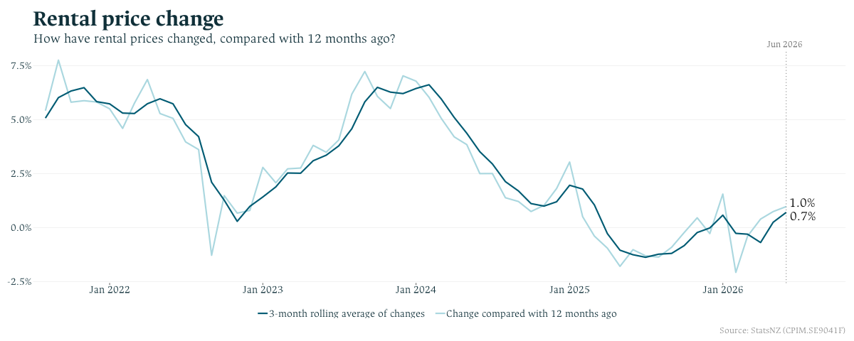
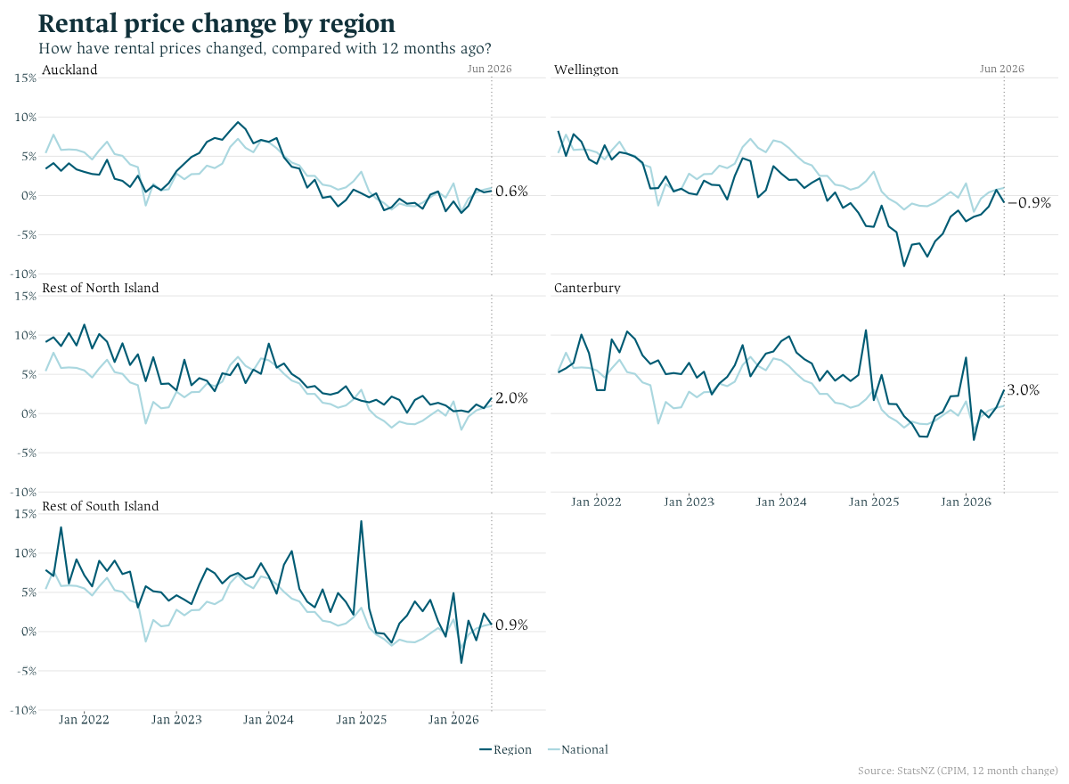

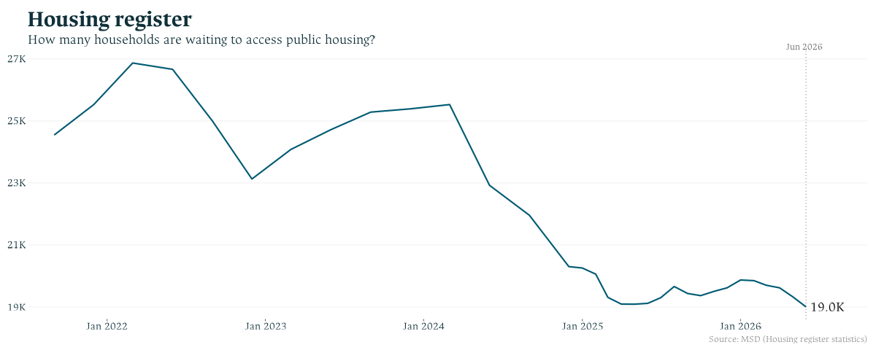
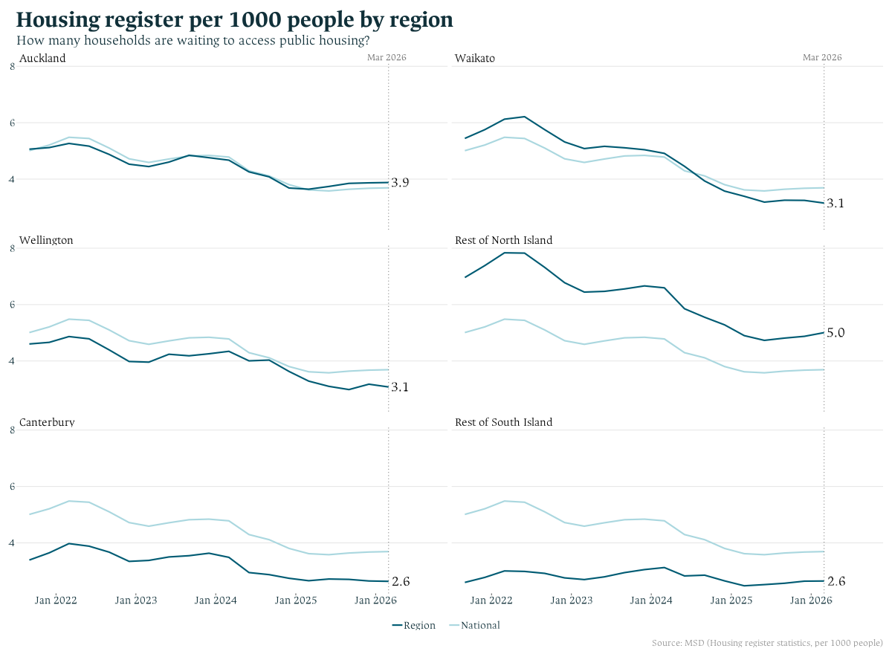

Property Market Charts
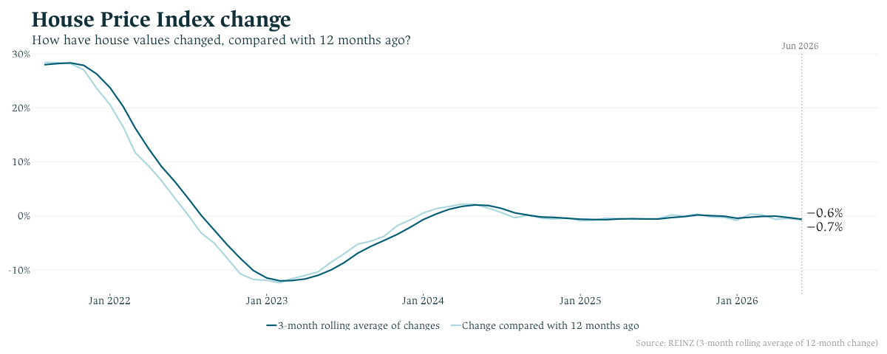
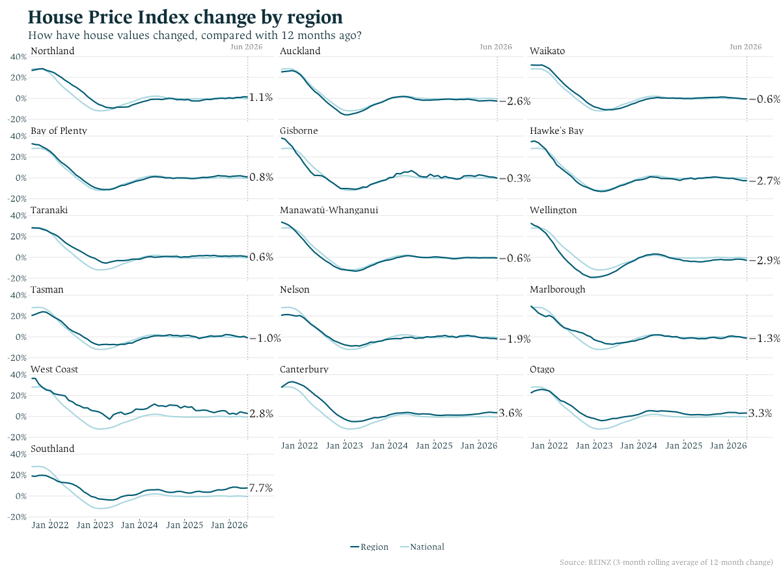

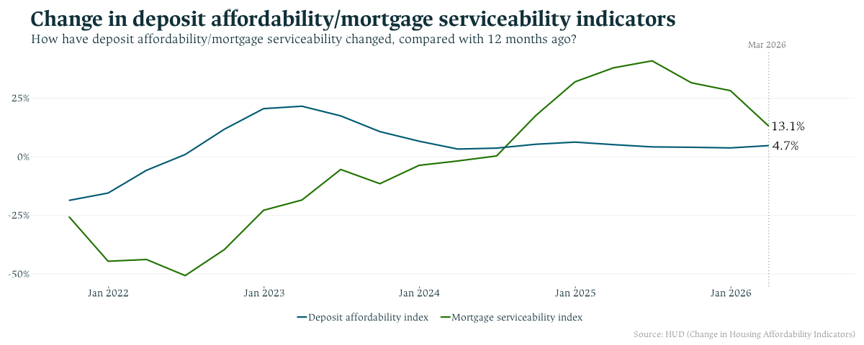
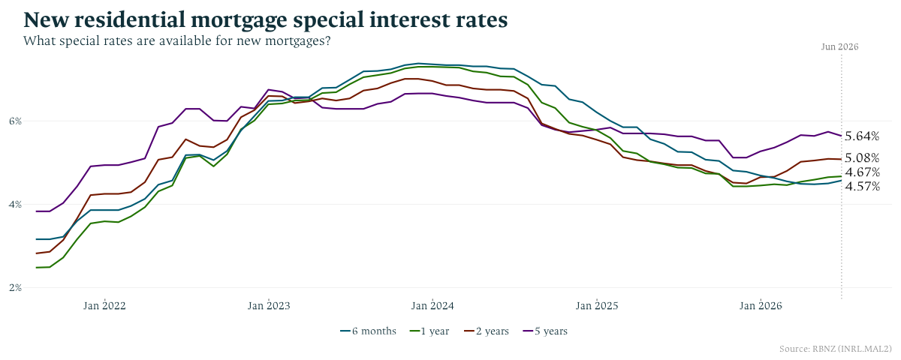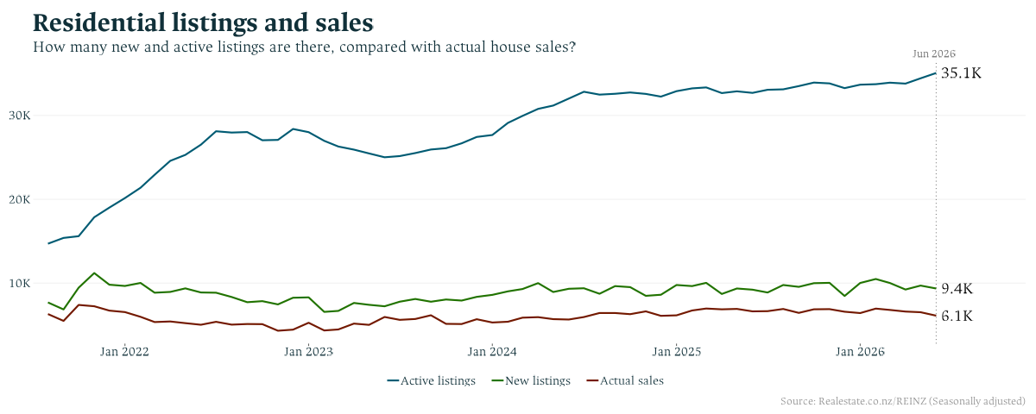
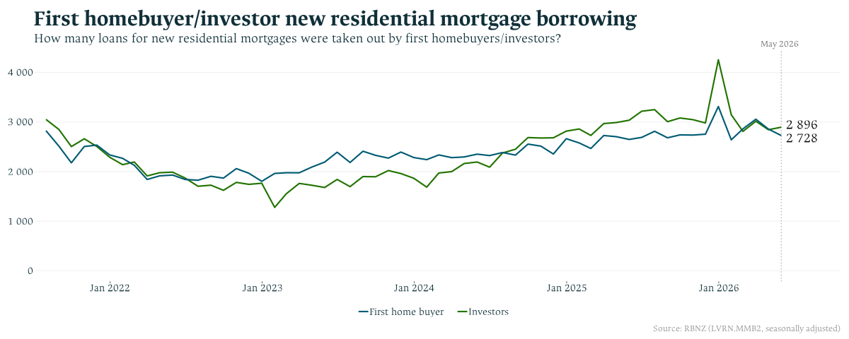

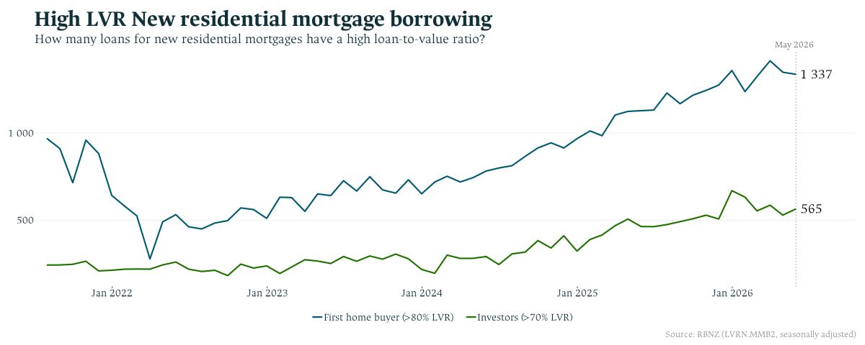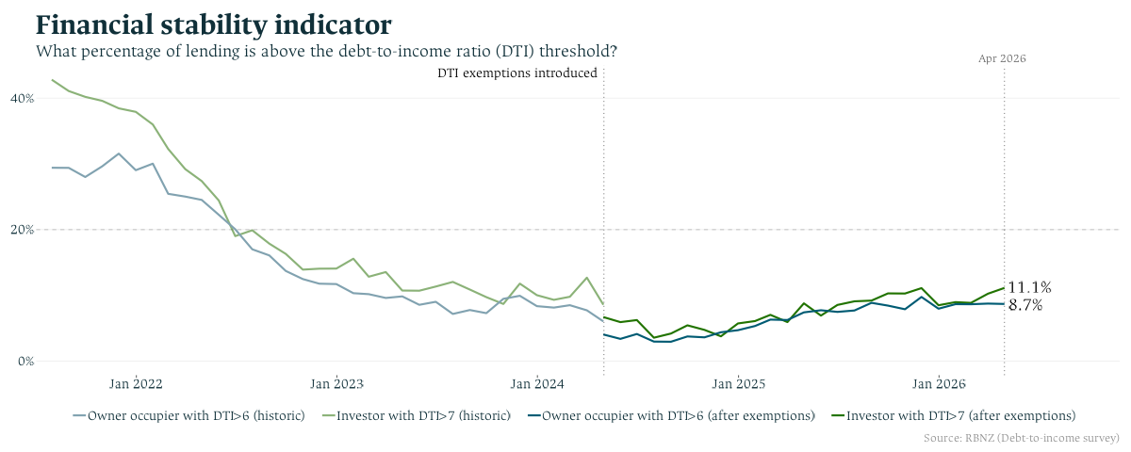

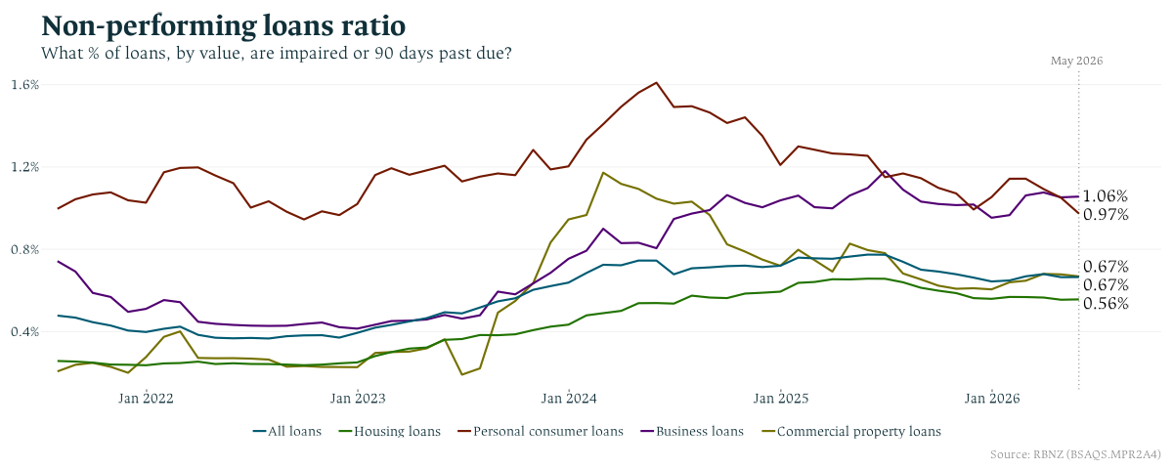
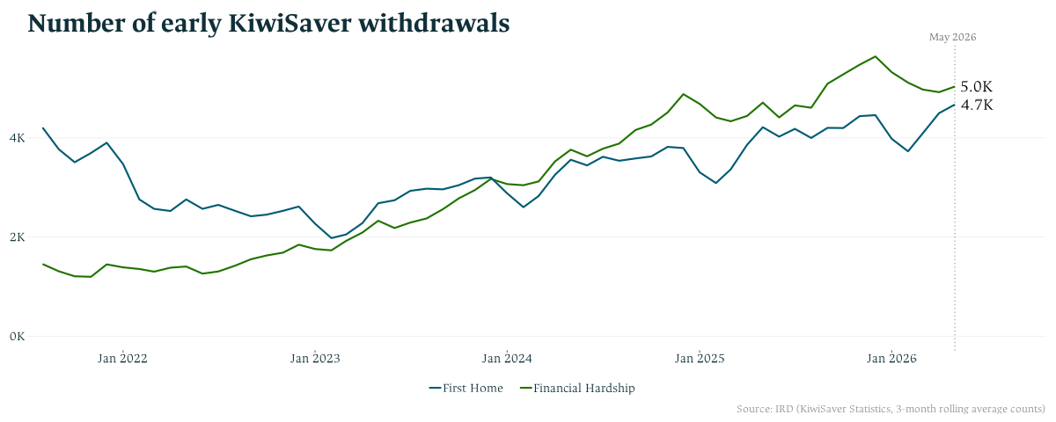

Residential Construction Market Charts

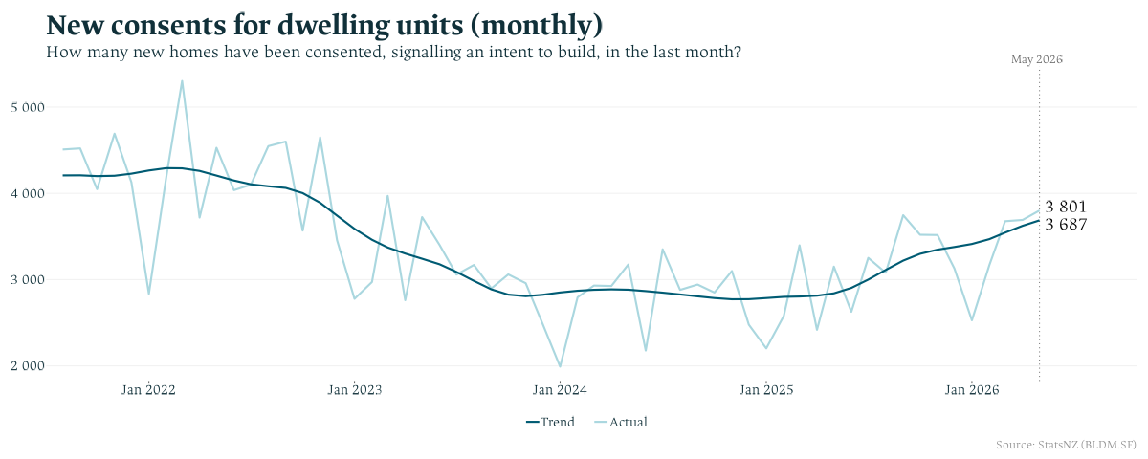

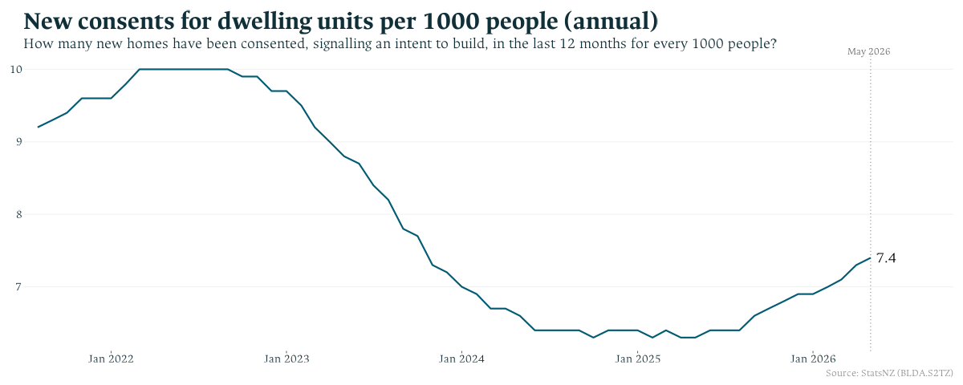

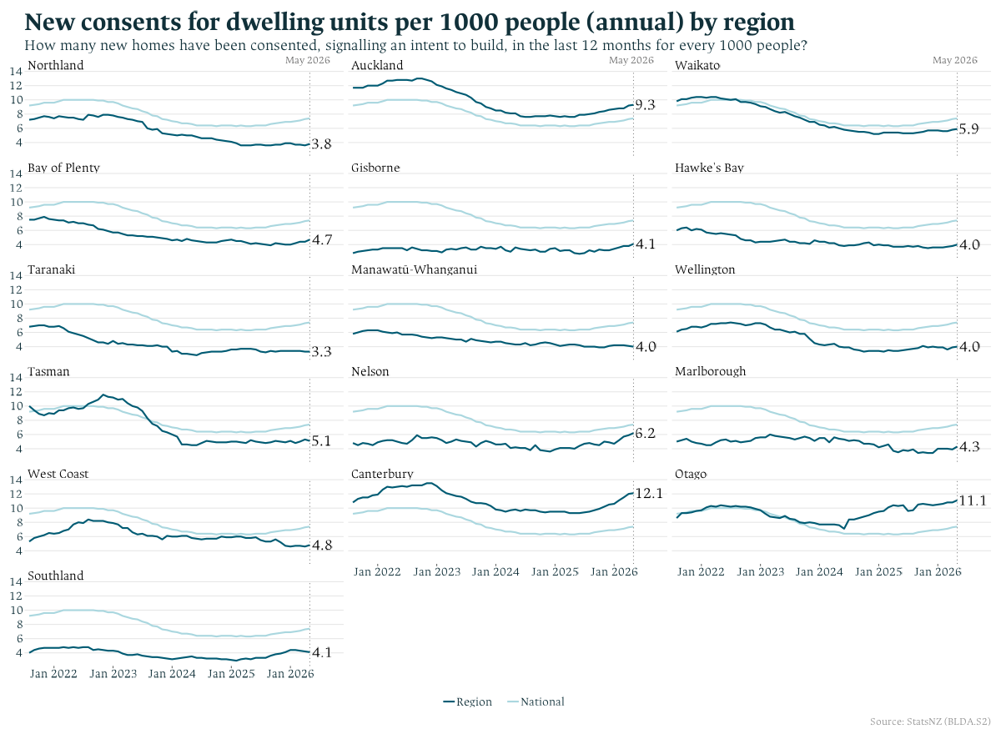
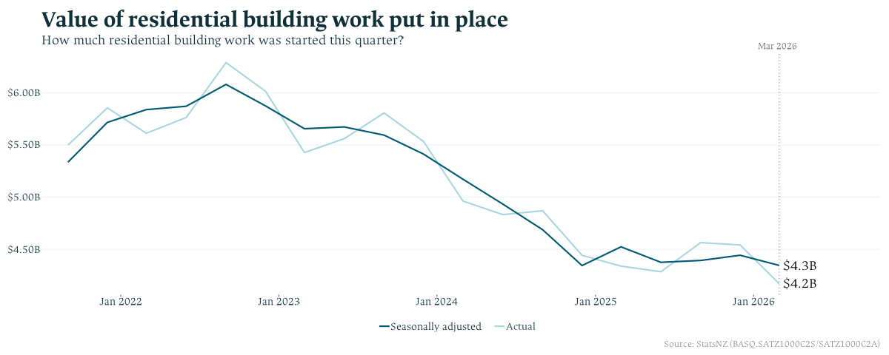
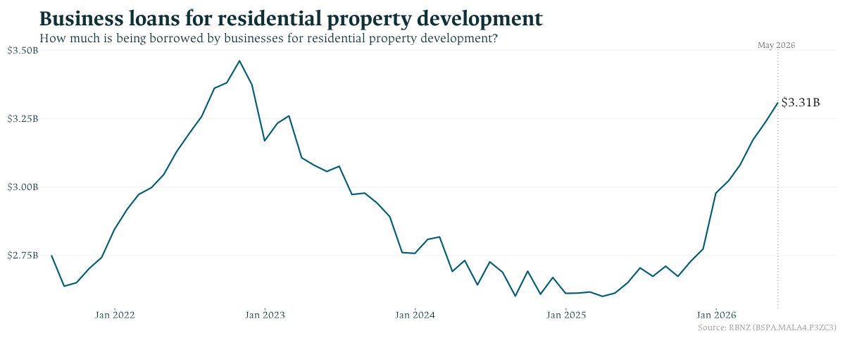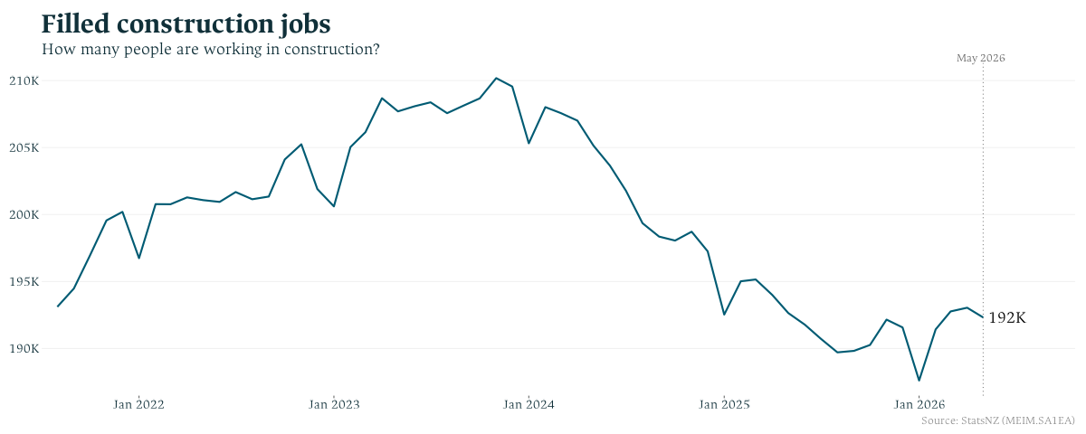
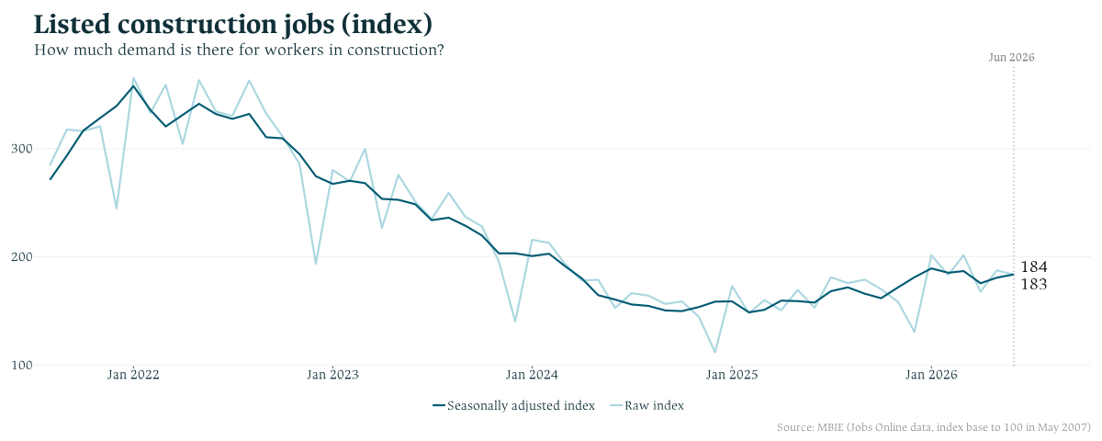

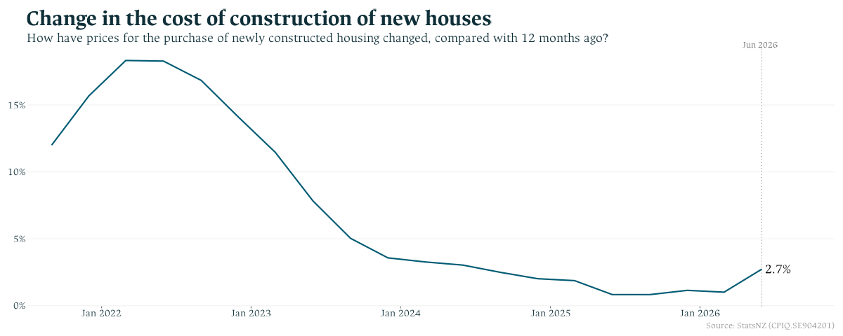

Macroeconomic charts
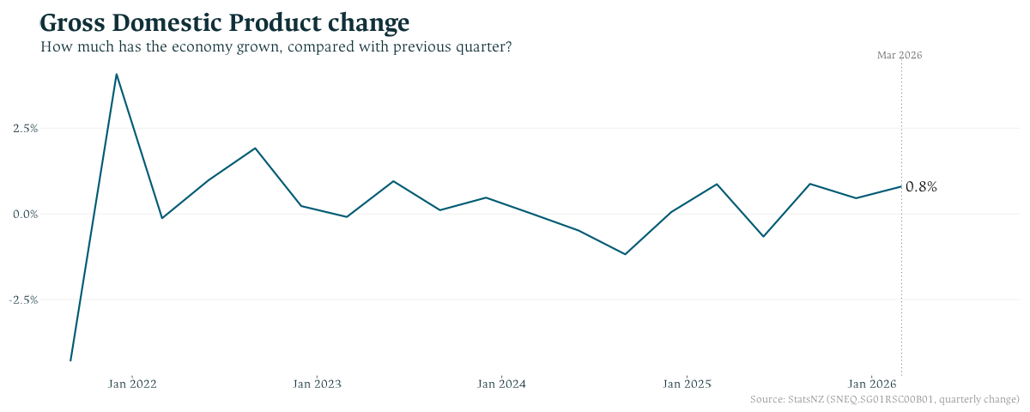
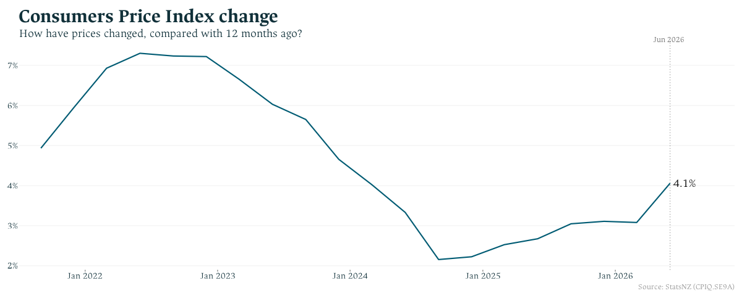
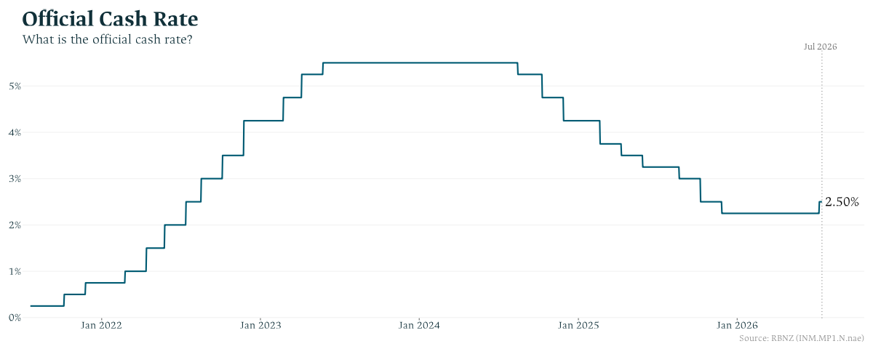
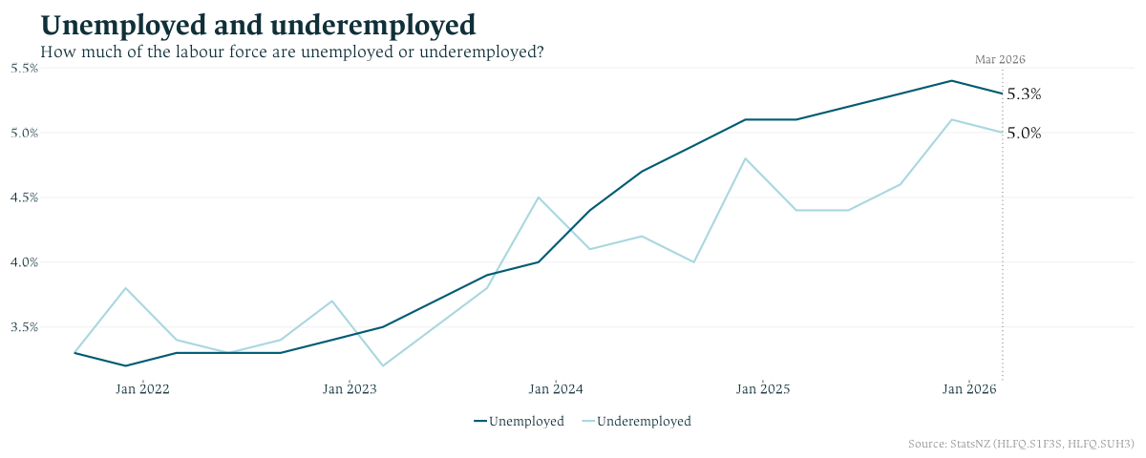
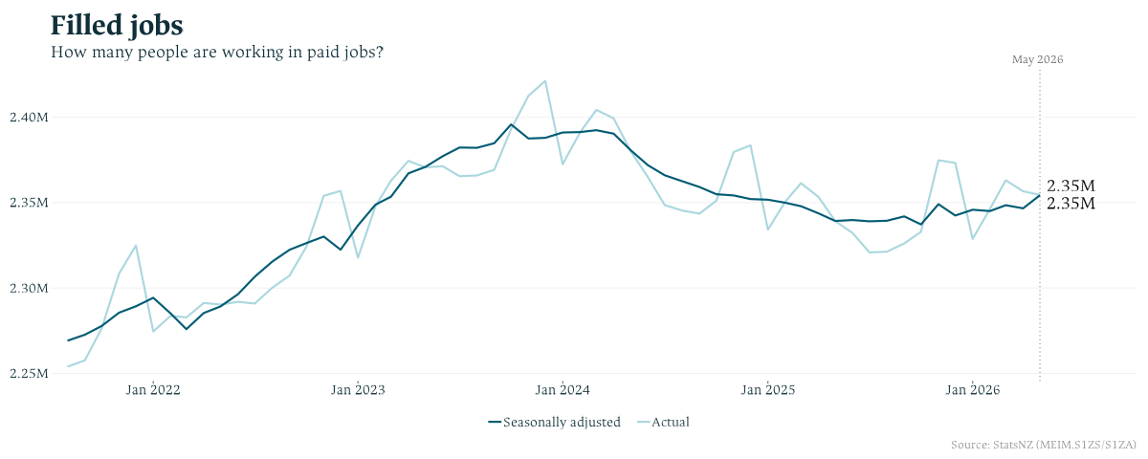
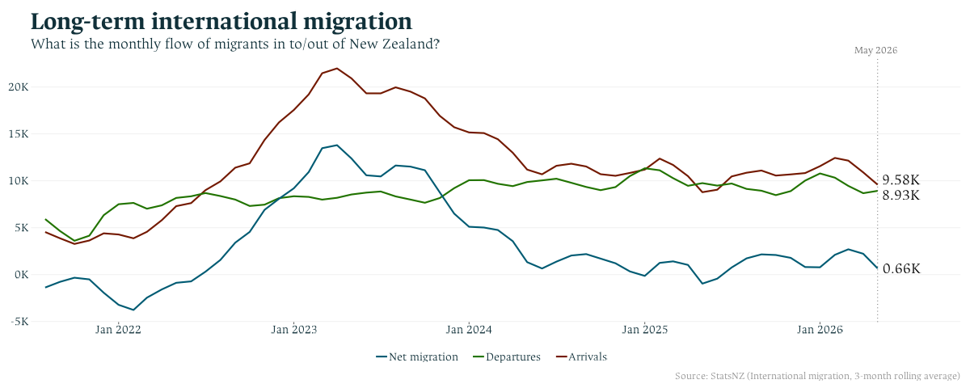

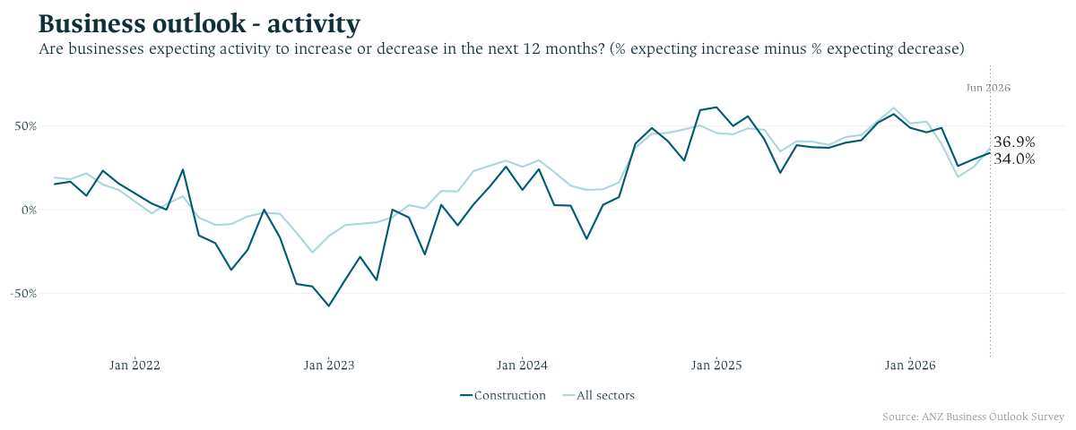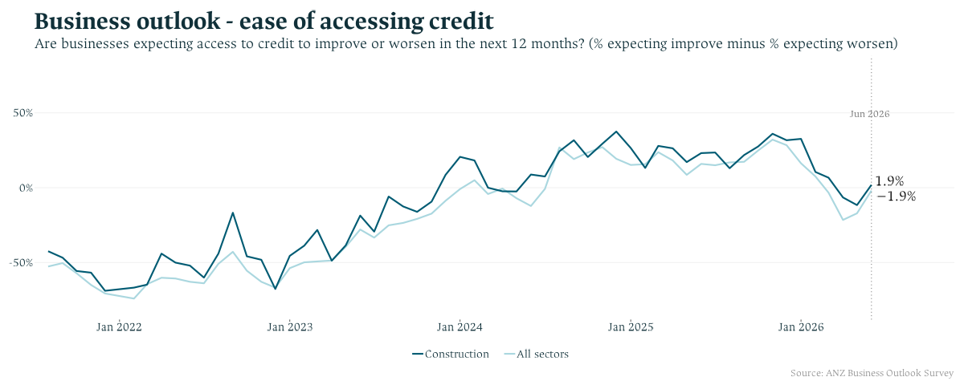

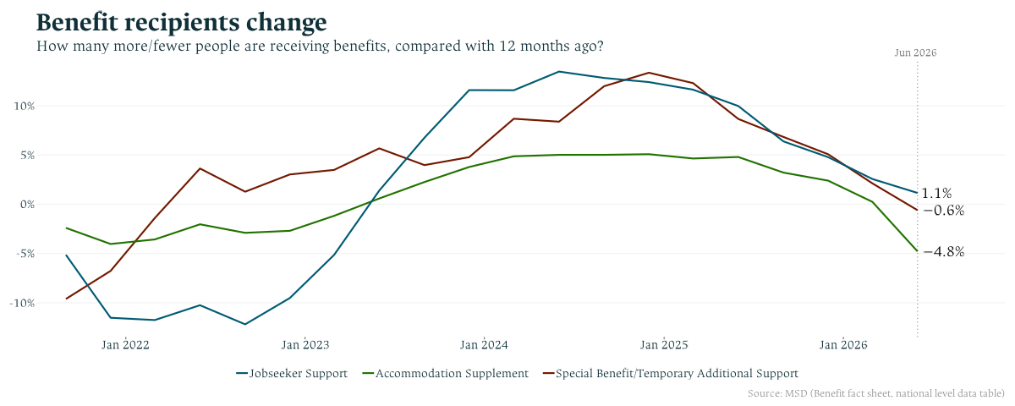

Stats NZ, March 2026, Gross domestic product.
Stats NZ, March 2026, Labour market statistics.
Stats NZ, May 2026, International migration.
Stats NZ, June 2026, Consumers price index (CPI).
RBNZ, July 2026, OCR increased to 2.50% to return inflation to 2%.
ANZ, June 2026, Business outlook survey.
Stats NZ, June 2026, Economic impacts on New Zealand from conflict in the Middle East.
Stats NZ, June 2026, Selected price indexes
MCERT, March 2026, Change in Housing Affordability Indicators
Over the year to the March 2026 quarter, rental affordability improved by 7.8% in Wellington, 4.4% in Waikato, 4.2% in Auckland, and 3.6% in Canterbury.
REINZ, July 2026, New Zealand property report
Realestate.co.nz, June 2026, New Zealand Property Market Report
RBNZ, June 2026, Financial stability indicators
RBNZ, May 2026, Residential mortgage lending by borrower type
Stats NZ, May 2026, Building consents
Stats NZ, March 2026, Work put in place
Stats NZ, June 2026, Consumer Price Index (Purchase of housing)

