


Housing market update
March Quarter 2026

Quarterly housing market update
The purpose of the quarterly housing market update is to provide Te Tūāpapa Kura Kāinga – Ministry of Housing and Urban Development, relevant housing agencies, the residential property and construction sector, and the wider public with an overview of housing and rental markets, residential construction, and broader economic conditions.
Each update features analysis of changes from the last quarter and the previous 12 months. It aims to provide a regular snapshot of current housing and rental market conditions by bringing a range of indicators together into one view and consider recent trends and emerging outlooks.
Any questions or feedback can be directed to hud.insights@hud.govt.nz.

Coverage and sources
This update covers statistics and information from the latest quarter – March 2026. However, where the data is lagged this will be noted. The update references a range of publicly available data and some internally produced data where noted.

Abbreviations and Terms
Abbreviations are used throughout this document for brevity. A glossary of abbreviations and key terms used can be found on page 9.

Our approach to analysing the housing market
Housing outcomes are shaped by many interconnected systems. Factors such as land use regulation, infrastructure provision, financial conditions, demographic change, and social services interact to influence housing costs, availability and quality, and people’s ability to access secure and stable homes.
On a quarterly basis, to understand changing trends in the housing market, we analyse three interconnected markets: rental, property, and residential construction.
Housing market data is subject to short-term volatility. To distinguish signal from noise, the Housing Market Update focuses on trends over time rather than individual monthly observations, and where possible prefers indexes over point measures such as medians.
We assess changes in the housing system using our affordability indicators, tracking changes in rental and house purchase affordability over time. We also combine leading indicators (for example, listings and consents) with lagging indicators (for example, house and rent price indices) to gauge current conditions and direction. This is set within the broader macroeconomic context and complemented by sector reports that data alone may not capture.

Table of Contents

Key insights 4
The economy 5
Rental market 6
Situation 6
Outlook 6
Property market 7
Situation 7
Outlook 7
Residential construction 8
Situation 8
Outlook 8
Glossary of key abbreviations and terms 9
General terms 10
Rental market charts 11
Property market charts 14
Residential construction market charts 18
Macroeconomic charts 22

Disclaimer

This publication provides analytical insight into housing, construction and economic conditions based on available data. It is intended to support understanding and discussion only. It does not constitute policy advice and is not to be relied upon for decision making. The Ministry does not guarantee the accuracy or completeness of the information or analysis, accepts no liability for any errors and no liability for any decisions based on its content. The Ministry may change, add to, delete from, or otherwise amend the contents of this publication at any time without notice.

Key insights
- In early 2026, New Zealand’s economy showed signs of stabilising, but the recovery remains delicate. After improving through the second half of 2025, annual Gross Domestic Product (GDP) growth reached 0.2% by December 2025, marking the first positive year since September 2024. However, faltering construction activity is contributing to an uneven recovery. Building consent numbers continue to rise into 2026, indicating positive intent that may be reflected in future GDP results.
- Annual inflation rose to 3.1% in the December 2025 quarter and remained at that level in the March 2026 quarter, while unemployment increased further to 5.4%. Net migration picked up modestly but remains much below pre-pandemic levels. In the context of heightened global instability, inflation risks and business uncertainty indicate potential slowing down of the domestic recovery through 2026.
- Rental inflation continues to soften nationally. Rental inflation has been easing since mid-2024, and that easing has continued with rents for new tenancies falling in the year to March 2026. Growth in existing-tenancy rents also slowed to its lowest level on record. Regionally, rental inflation for new tenancies has eased across most of the country, with rents continuing to fall in Wellington and Auckland, while rental inflation in Canterbury has been generally rising, but with some volatility.
- House prices remained flat in early 2026, with the House Price Index (HPI) unchanged over the year to February, as high listings and slightly lower sales volumes weighed on growth. Regional divergence persisted, with most North Island centres declining while South Island markets recorded modest gains.
- Rising mortgage rates and subdued economic conditions continue to constrain demand, although first home buyer activity has remained strong through improved affordability and greater choice due to elevated number of listings for sale. Despite some easing in credit conditions, looser loan to value ratio (LVR) restrictions, weak labour market conditions, soft net migration, projected interest rate rises and global uncertainty are expected to keep house price growth subdued in the near term.
- The outlook for residential construction has continued its positive tone in early 2026, supported across key regions, and indicators such as rising development lending and a slight lift in employment. However, conditions remain challenging, with cost pressures rising, flat demand for additional labour in the near term, and high firm liquidations pointing to ongoing financial strain in the sector. Intention to build is trending up marginally from its lows in 2024. Looking ahead, geopolitical risks, rising input costs, and weak housing demand are expected to weigh on activity, meaning any recovery in construction is likely to be gradual and fragile.

The economy
The New Zealand economy remained under pressure throughout 2025, though tentative improvements began to develop towards the end of the year and signs of stabilisation continued into 2026. However, sustained labour market weakness and emerging volatility in the global landscape continue to disrupt the already fragile economic recovery.
Modest domestic recovery tempered by persistent headwinds
Annual GDP growth of 0.2% for the year ending December 2025 marks the first annual economic growth since the year ending September 2024. Over the quarter GDP grew by 0.2% in the December 2025 quarter, following a quarterly increase of 0.9% in the September 2025 quarter.
However, momentum in construction was not sustained. After expanding 0.8% in the September quarter, construction output fell again by 1.4% in the December 2025 quarter, making it a key drag on otherwise broad GDP growth. The year 2026 has seen continued rise of building consents issued, indicating enduring positive intent that may be reflected in construction sector’s contribution to GDP, although global political disruption might have an impact.
Inflation has edged up, with the Consumers Price Index (CPI) remaining at 3.1% for the year ending March 2026, reflecting continued price pressures in the economy.
Labour market conditions remain under pressure, with unemployment rising to 5.4% in the December 2025 quarter. Rising unemployment continues to affect housing and rental affordability for those impacted and tends to dampen confidence more broadly.
Net inward migration has seen a modest increase, with net migration of 25,200 in the year ended February 2026, compared with a gain of 17,700 in the previous year. While a positive shift for economic activities and consumer demand, this remains well below the long-term pre-COVID trend.
Global disruptions pose fresh challenges
Heightened geopolitical instability is introducing new inflationary pressures that could complicate the domestic recovery trajectory.
Business confidence strengthened through 2025, however, began to ease in early 2026 before declining sharply in March 2026 as the initial implications of the Middle East conflict are realised. Flow-on impacts from the Middle East conflict include higher fuel and transport costs with immediate pressure on freight and distribution costs, while construction materials are also indicated to rise due to higher petrochemical input costs. These pressures are likely to spillover to food and other essentials further increasing cost-of-living pressure for lower-income households going into winter. This comes as the demand for support services is already elevated.
The Reserve Bank (RBNZ) held the Official Cash Rate (OCR) at 2.25%, although signalling an increase before the end of the year. They consider the situation to be different from the COVID-19 and Ukraine war shocks, as demand is currently more subdued, and therefore the broader inflationary pressure is expected to be less acute. However, the medium-term implications for inflation will largely depend on the duration and severity of any supply disruption and price-setting.

Rental market

Situation
Rental inflation continues to soften
In the year to March 2026, rents for new tenancies fell by 0.4%, while rents for existing tenancies rose by 0.7%. This is the smallest annual increase in rents for existing tenancies since the series began in 2006. Rental inflation for new tenancies has been declining since mid-2024 and remains well below the elevated inflation seen in 2023.
Regionally, rental inflation has cooled across the country. Annually, rents for new tenancies in Canterbury has been volatile, with periods of decline followed by sharp growth; momentum has since eased, with a 0.4% increase. Rents in the Wellington region continue to decline (-2.4%), although at a slower pace than last year. In Auckland, rents are down 1.3% annually and have been trending downward over the past four months.
Rental affordability continues to improve, but unevenly with regional variance
Nationally, rental affordability for new tenancies declined slightly (‑0.8%) in the December 2025 quarter, following a quarterly increase of 2.2% in the September 2025 quarter.
Wellington recorded the largest increase in rental affordability (7.9%) to December 2025, reflecting ongoing declines in rents. Rental affordability also improved across most regions, while it was broadly flat in Southland (0.0%) and fell in Canterbury (‑0.2%) and Tasman (‑0.7%), where rents increased faster than median household incomes.
Landlords are facing increased competition as rental supply has lifted, and tenant demand has dropped. As a result, longer vacancy periods are placing downward pressure on asking rents, supporting continued subdued rental inflation for new tenancies and possible further rent declines where supply demand imbalances remain.

Outlook
Rental inflation is expected to remain low through mid‑2026, reflecting subdued migration, elevated supply from recent dwelling completions, and cooling wage growth.
Regional pressures are likely to diverge. The stronger local economies like in Southland and Canterbury, driven by growth in dairy sector and internal migration, are likely to see higher rental demand and renewed pressure on rental affordability.
Overall rental inflation has continued to ease, with rents for new tenancies falling annually and growth in existing tenancy rents at its lowest level since the series began. Looking ahead, elevated rental supply, longer vacancy periods, and subdued demand are expected to keep rental inflation low through mid‑2026, with increasing divergence across regional markets.

Property market

Situation
National prices remained broadly flat in the first quarter of 2026, reflecting high listings and North Island declines offset by South Island rises
Over the year to March 2026, house price inflation grew slightly (0.2%), although significant regional variation persisted, consistent with trends observed over the past year. Several South Island markets recorded positive price growth (Otago, Canterbury, and Southland grew 3.6%, 3.7%, and 7.9% respectively), with declines in most North Island centres (Auckland -1.2%, Waikato -0.3%, and Wellington -1.8%).
The decline in HPI across many regions has been driven by elevated housing inventory and slightly lower volumes of sales in the first quarter of 2026. Active listings nationally reached a decade high for March 37,500 (up 2.1% year-on-year), reflecting a steady build-up of newly constructed houses coming to the market since 2022 in response to high demand post COVID-19 from high levels of net migration and loose monetary policy settings.
Strong First-Home Buyer activity amidst rising mortgage rates while overall demand remains soft
First-Home Buyers’ (FHBs) strong activity despite rising mortgage interest rates, since November 2025, is supported by declining house prices in some regions, relatively modest income growth improving deposit and mortgage serviceability, and greater choice from high for-sale inventory (37,638 listings). Investor activity, except for a spike in late 2025, remains subdued.
First-Home Buyers are continuing to make use of the ability to borrow at high debt to income (DTI) ratios (8.7% of owner occupiers – which includes FHBs - in February 2026 with DTI >6) and loan to value (LVR) ratios (51% of new FHB lending was above 80% LVR) but banks are still well below their limits on this type of lending. Despite this increased access to credit with lower LVR restrictions, overall housing demand remains constrained by weak labour market conditions, weak net migration, subdued economic activity and current global uncertainty.

Outlook
In the near-term, the average national house price growth is expected to be subdued unless economic conditions strengthen
The current global environment has weakened business confidence and increased uncertainty, alongside ongoing inflationary pressures. The current fuel price induced inflationary pressures may bring forward OCR increases. Banks are already pricing in higher rates into short term mortgage rates with longer term rates already increasing as a result of rising wholesale swap rates. This may soften demand further. So, without an increased economic momentum which generally leads to a lift in net migration increasing demand, house prices are likely to remain flat or decline further. Mortgage serviceability, which improved as mortgage rates fell over the past year, is expected to stabilise as rates edge higher. Rising council rates and insurance costs are adding pressure, with flood-risk-related insurance coverage in high-risk areas (for example, Westport) weighing on affordability.

Residential construction

Situation
Early signs of momentum in construction activity, but conditions remain challenging
Indicators across financing and labour markets suggest some ongoing resilience in the sector, albeit with mixed signals. Residential development lending has been trending upward since mid-2025, increasing by 18% in February 2026 compared to a year earlier, amidst 3.0% annual growth in construction costs in the March 2026 quarter (fastest in the last 2 years). Labour demand has shown a modest recovery following seasonal declines, with construction employment rising slightly (up 0.3% since October 2025), although demand for more workers (online job advertisements) has remained flat.
Despite these signs, trading conditions remain challenging, and developers continue to act cautiously. Even prior to recent fuel cost pressures, projects were being scaled back, staged, or redesigned to improve cost efficiency, but margins are still being compressed. The sector also continues to face financial strain, with the construction industry remaining at the highest level for company liquidations—769 firms over the past year, equivalent to 0.9% of the sector.
Intentions to build in near-term are marginally trending up after the lows in 2024, recording a shift toward higher-density housing
Building consents are marginally increasing after their decline in 2024. In the year to February 2026, a total of 37,534 new dwellings were consented (up 11.7% compared to last year). These figures precede the uncertainty introduced by the escalation of the US–Iran conflict. The growth in consenting has been seen across both islands, particularly in Canterbury, Otago, Auckland, Waikato, and Wellington. There has been a compositional shift in dwelling types since 2023, with multi-unit developments now making up a larger share of consents (more than 52%) compared to standalone houses, increasing relatively more affordable options in the pipeline.

Outlook
Construction outlook weighed down by cost pressures, geopolitical and economic uncertainty
Looking ahead, the outlook for the construction sector is cautious. Heightened geopolitical tensions and the oil shock are placing further upward pressure on material costs at the same time as weaker economic conditions and flat house price expectations are likely to dampen buyer demand. In this environment, developers may delay or scale back new projects or liquidate, particularly as financing and construction costs remain elevated reducing margins.
Taken together, these factors suggest that any recovery in building activity is likely to be gradual and fragile rather than immediate, with near-term activity expected to remain subdued.

Glossary of key abbreviations and terms
CCC | Code compliance certificate: A formal statement issued by the local consent authority, that building work carried out under a building consent complies with that building consent.
CPI | Consumers price index: The CPI is a measure of inflation for New Zealand households. It records changes in the price of goods and services. It influences interest rates and is used to calculate changes to benefit payments.
DTI | Debt to income levels: Restrictions put in place on the amount of lending that a bank can make to owner occupiers with a DTI of 6 or above and investors with a level of 7 or above.
FHB | First home buyer: Someone buying their first home.
GDP | Gross domestic product: Reported quarterly, provides a snapshot of the performance of the economy. GDP is New Zealand's official measure of economic growth. Two quarters of negative growth is classed as a recession.
GFC | Global financial crisis: The period of extreme stress in global financial markets and banking systems between mid-2007 and early 2009.
HPI | House price index: The index measures price change over time and is a better measure of market change than median or average sales prices, which can be heavily influenced by the composition of sales. Our preferred HPI is from REINZ.
LVR | Loan to value ratio: Limits on the amount of credit that banks can extend to mortgage borrowers with high LVRs (low deposits). This lessens the potential for large mortgage losses in the event of a significant correction in the housing market. LVR restrictions were implemented in October 2013 and have been adjusted from time to time.
OCR | Official cash rate: The official cash rate is set by the Monetary Policy Committee at the Reserve Bank. Monetary policy and OCR’s primary purpose is to retain an ‘inflation target of 1% to 3% over the medium-term, with a focus on the 2% mid-point’. A ‘neutral’ OCR is an interest rate band at which the rate neither stimulates nor restrains the economy.
RPI | Rental price index: The RPI measures changes in rent for private sector rentals. The ‘flow’ measure captures changes for dwellings that have a new tenancy started in the reference month. The ‘stock’ measure shows rental price change across the whole rental population – including current tenancies. Rents for existing tenancies tend to be ‘sticky’ (rise and fall more slowly), due to contractual and relationship-based considerations.
RBNZ | Reserve Bank of New Zealand: Aotearoa New Zealand’s central bank with responsibilities including managing inflation and monetary policy, with a core focus on the OCR.
STR  Rental affordability  Deposit affordability  Mortgage serviceability | Mortgage service test rates: Used to assess a borrower’s ability to service payments should rates rise above the current borrowing. Rates can be between 1.5% to 2.5% above market rates. Test rates don’t always adjust immediately when interest rate changes.  The change in rental affordability indicator compares changes in rental prices for new tenancies with the growth in median household disposable (after tax) income. Factors that can affect rental affordability are rental prices and household disposable income.  The change in deposit affordability indicator compares changes in house sales prices with the growth in median household disposable (after tax) income. Factors that can affect deposit affordability are house sales prices and household disposable income.  The change in mortgage serviceability indicator compares changes in the purchasing power of mortgage interest payments for new home loans with the growth in median household disposable (after tax) income. Factors that can affect mortgage serviceability are mortgage interest rates, house sales prices, and household disposable income.

General terms
Index: Tracks value change over time, from an original benchmark but does not provide a value itself.
Seasonal adjustment: Removes the influence of seasons from a series, for example, buyer interest in the warmer months of the year can affect price.
Structural and cyclical: Structural refers to fundamental, long-term shifts in an economy, while cyclical refers to short-term fluctuations tied to the business cycle.
Tradeable and non-tradeable inflation: Components of the CPI, tradeable inflation coming from the price changes for imports and non-tradeable being based on domestically created products and services.
Also see: Statistical terms and concepts glossary | Australian Bureau of Statistics (abs.gov.au)

Rental market charts
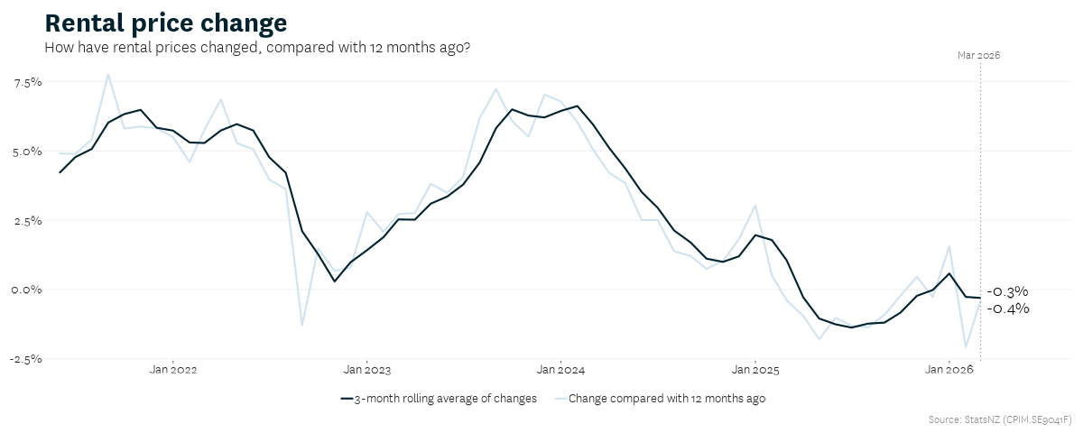

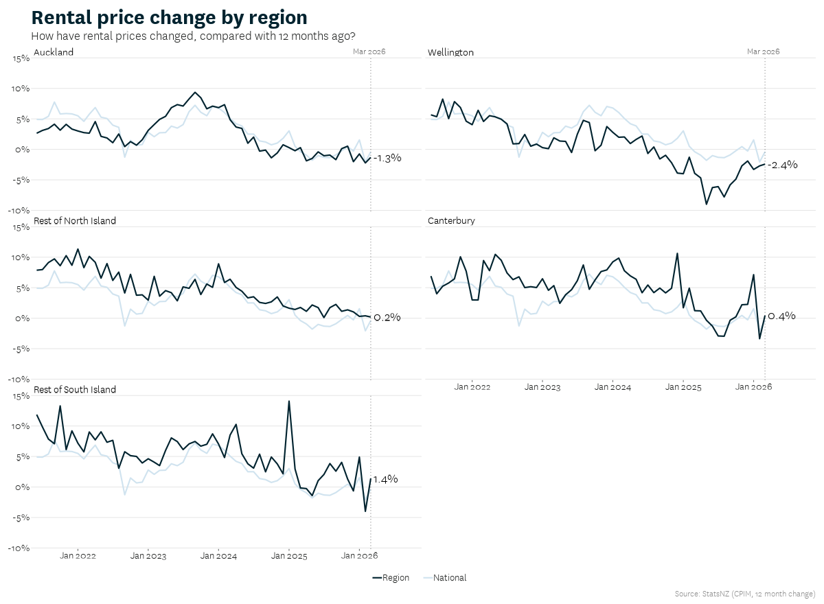

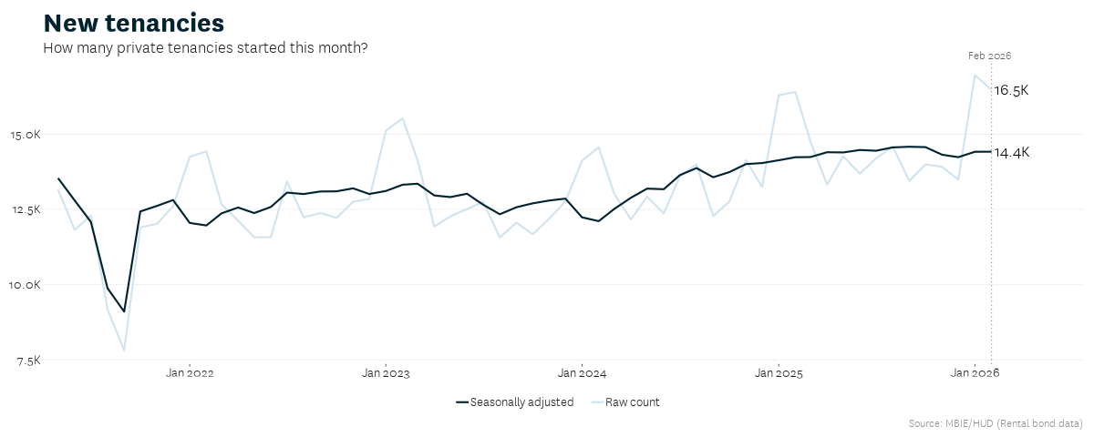

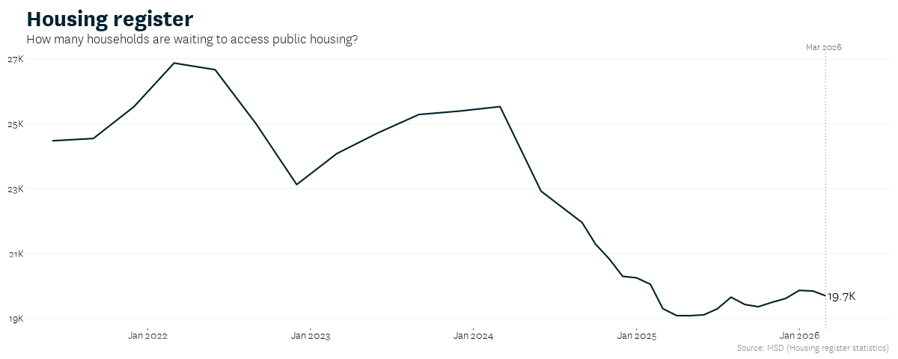
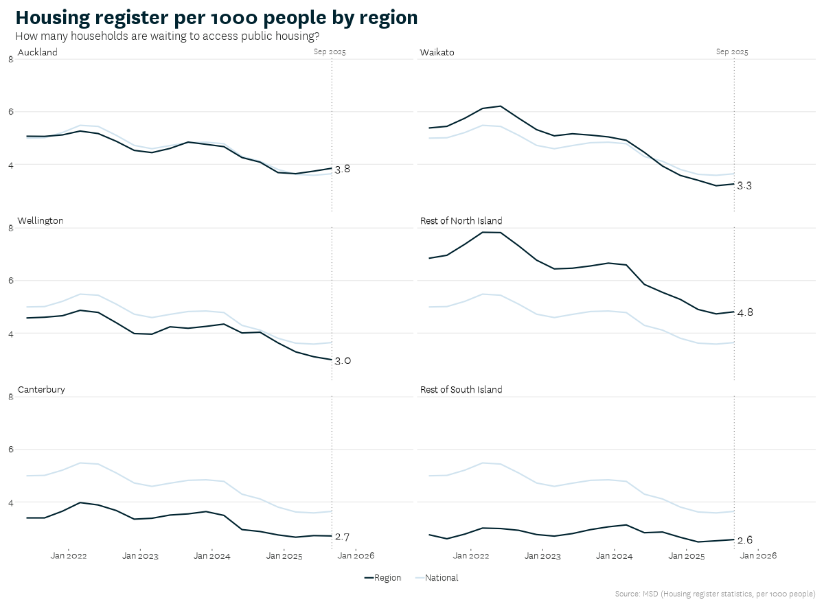

Property market charts
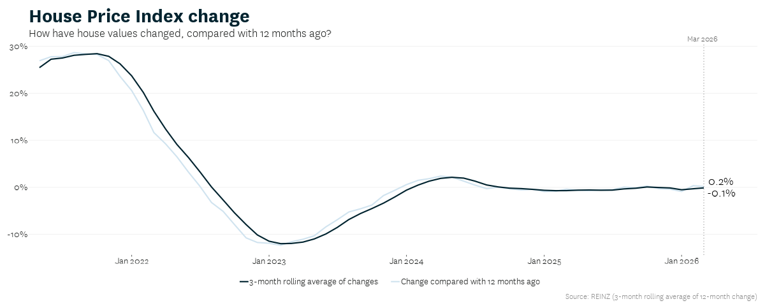
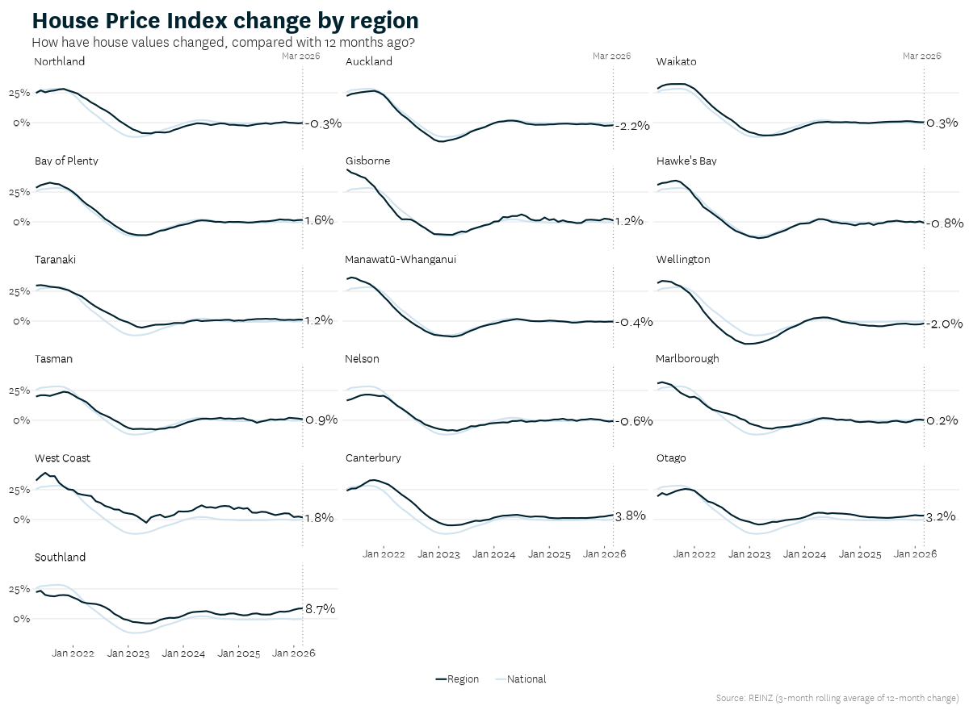

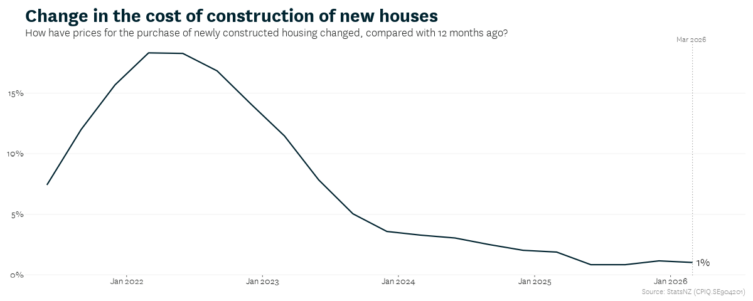
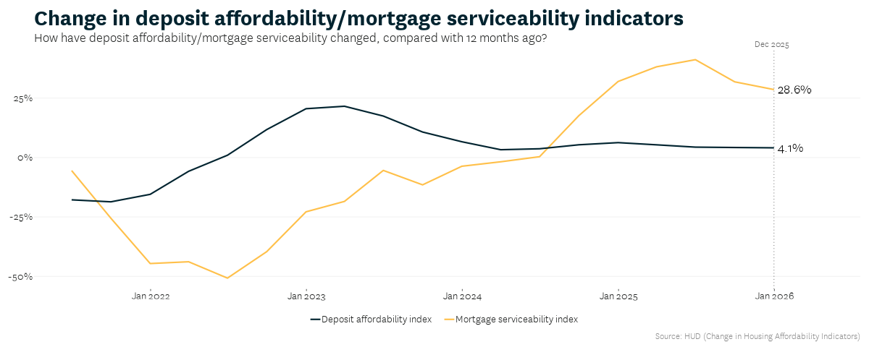
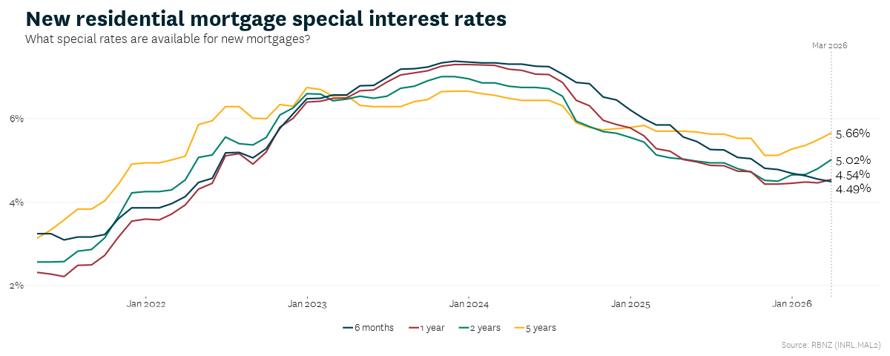
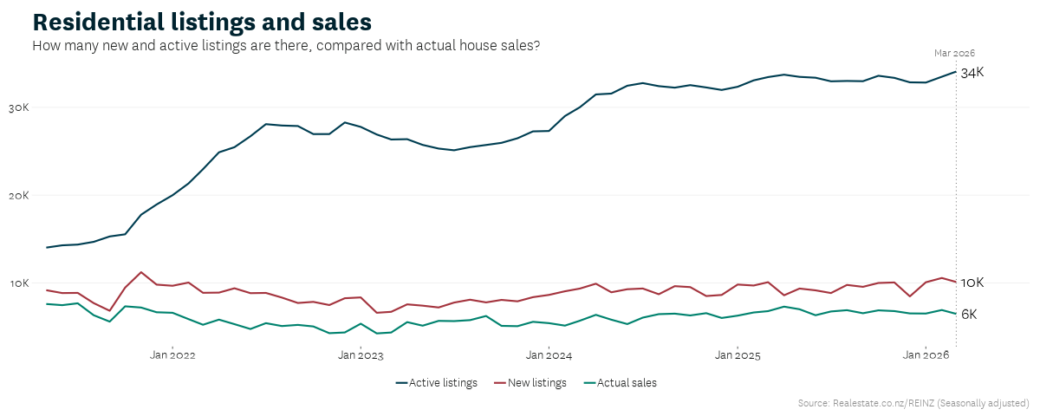
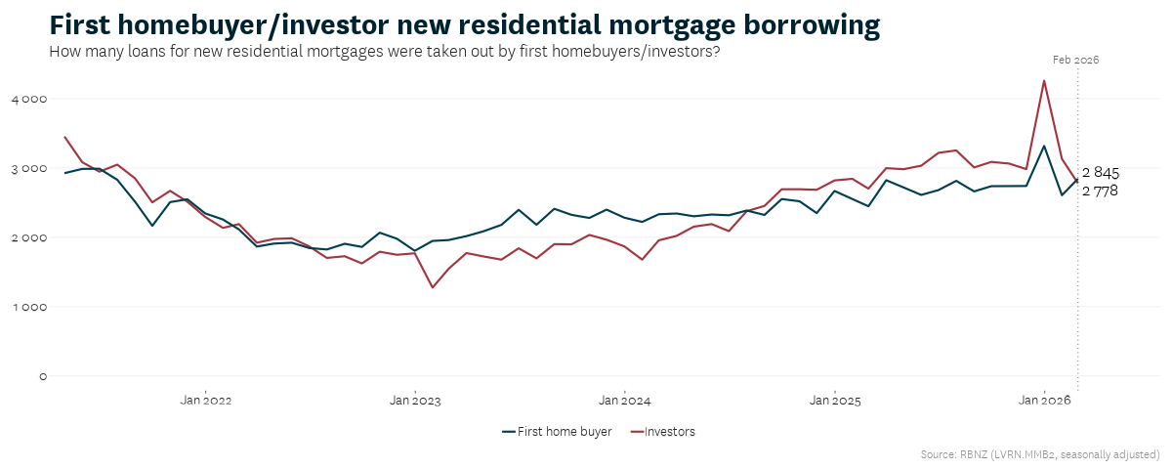
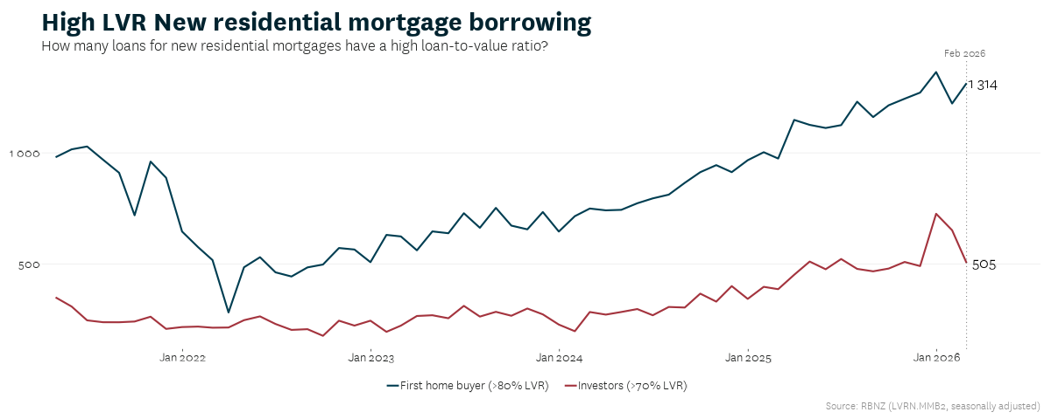
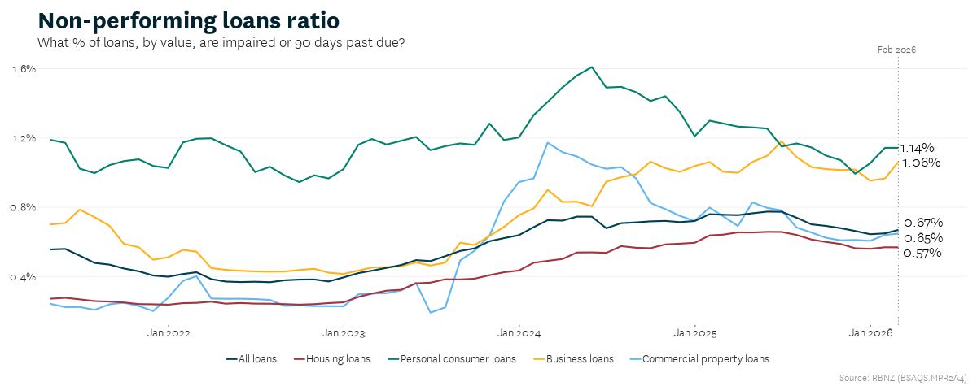
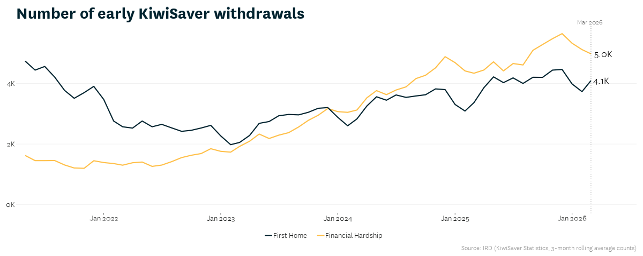

Residential construction market charts
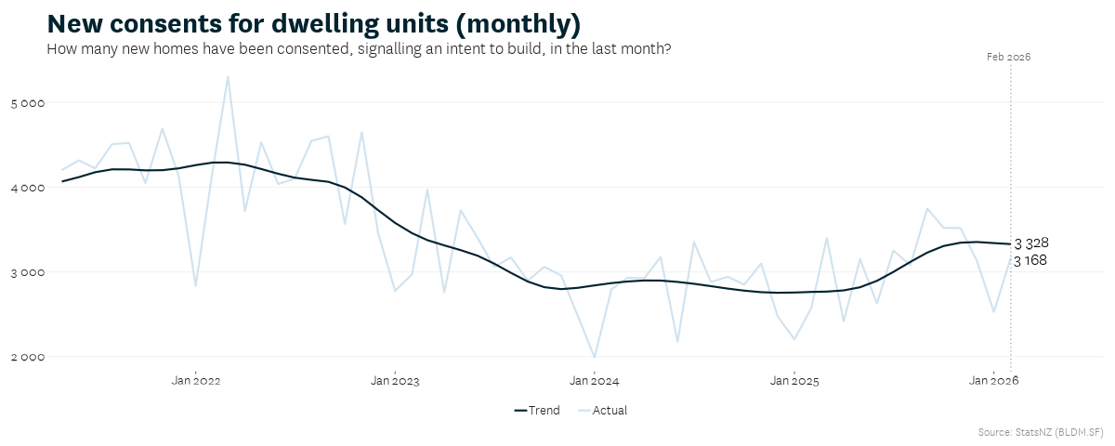
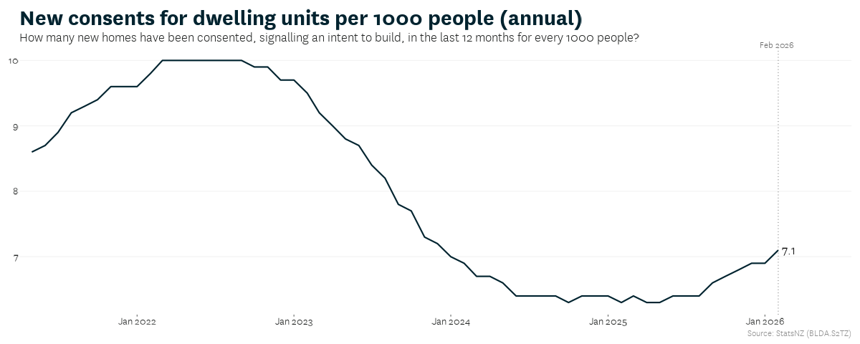
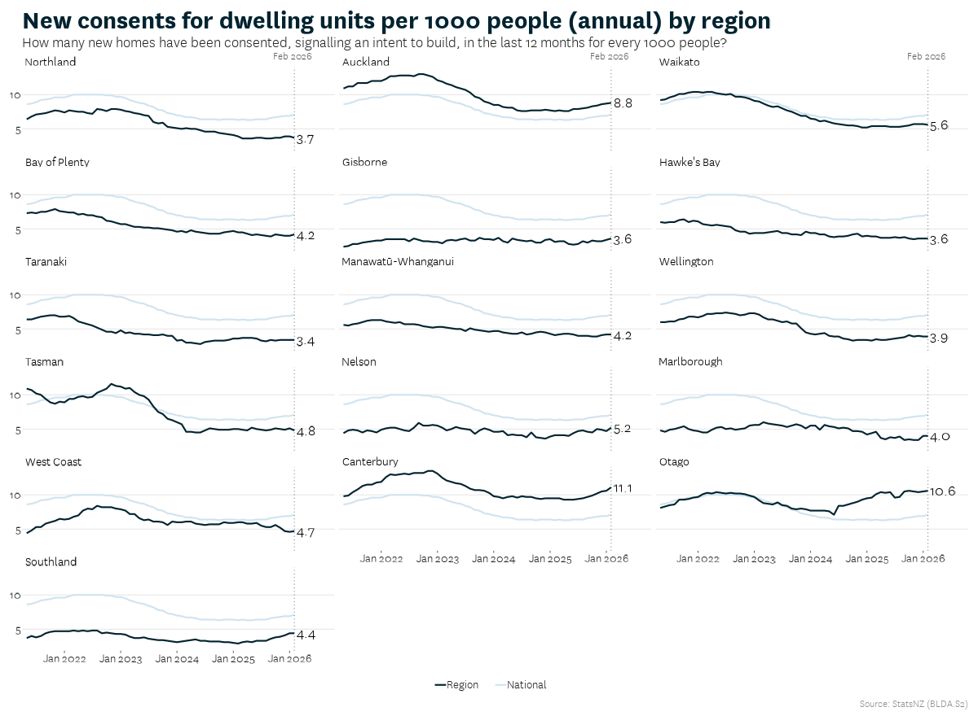
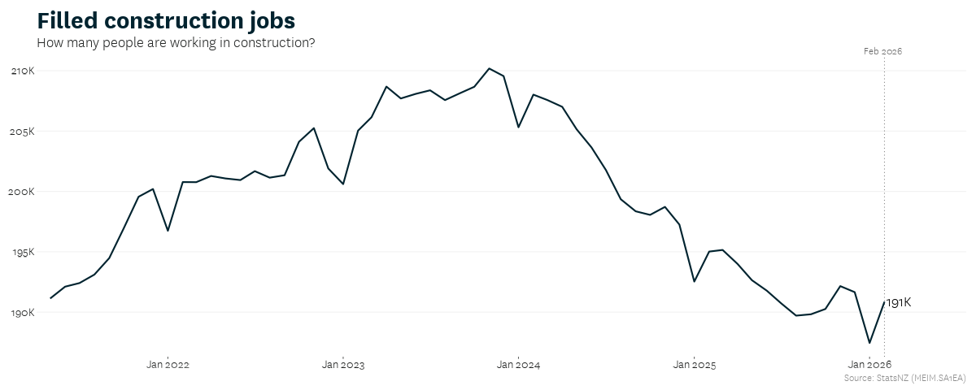
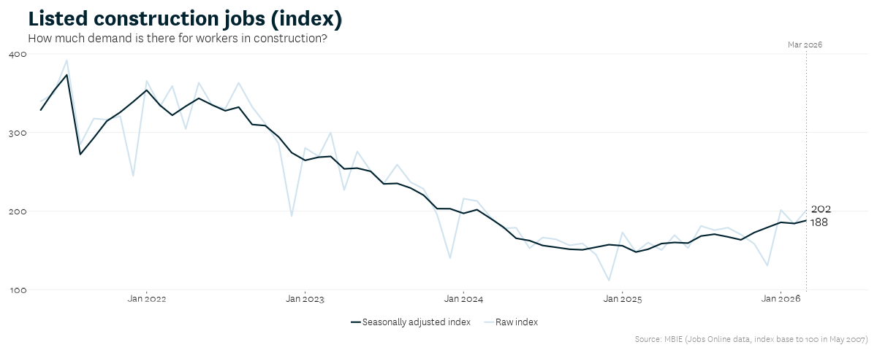
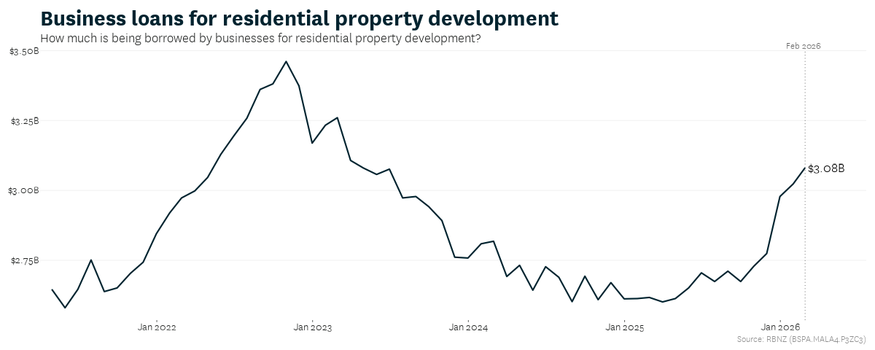
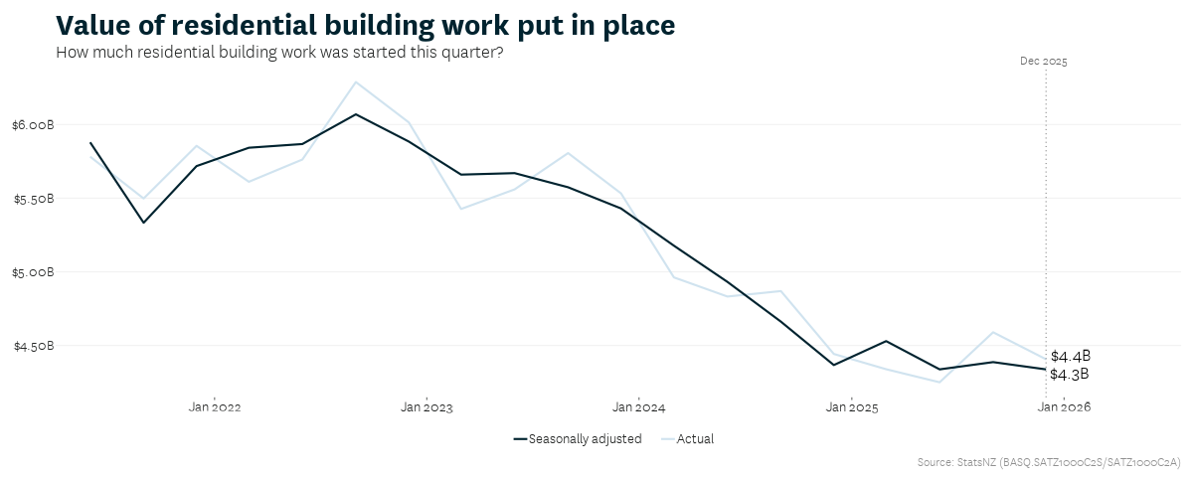

Macroeconomic charts
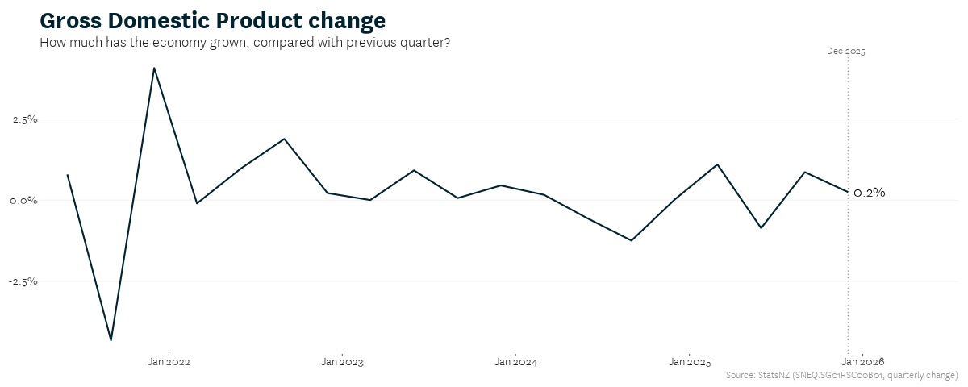
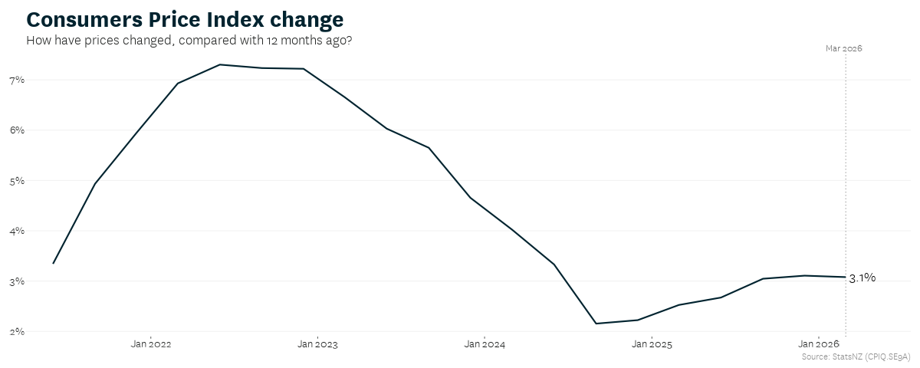
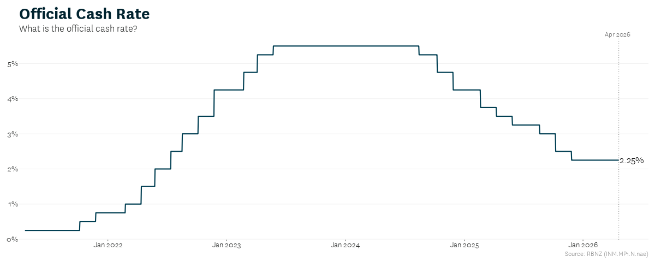
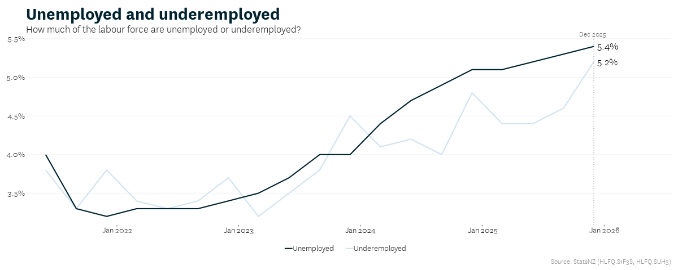
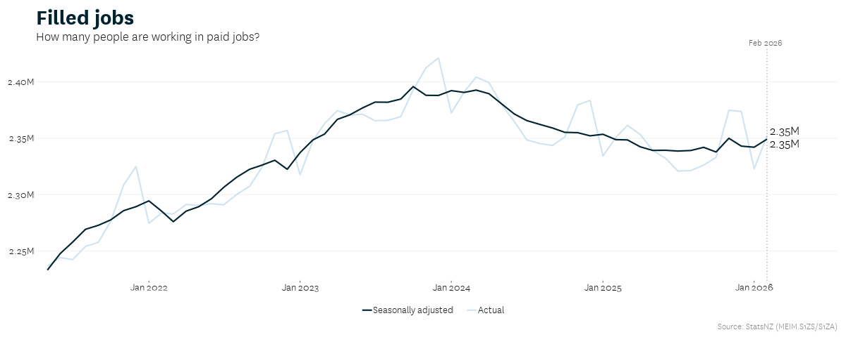
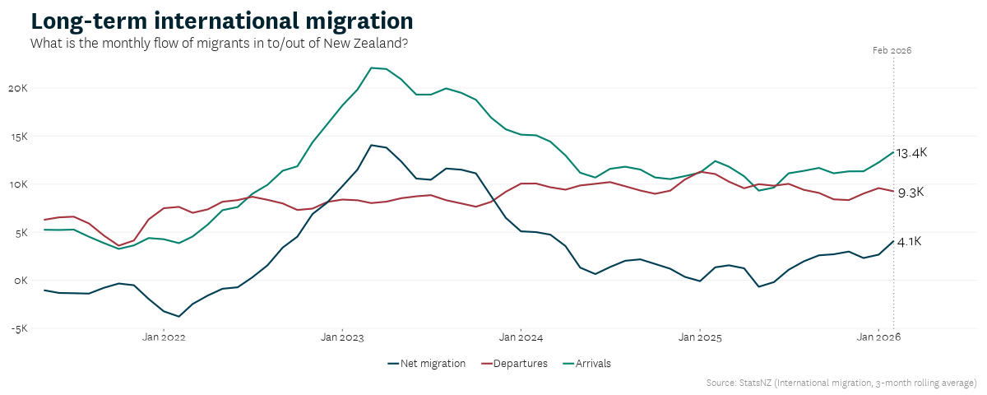

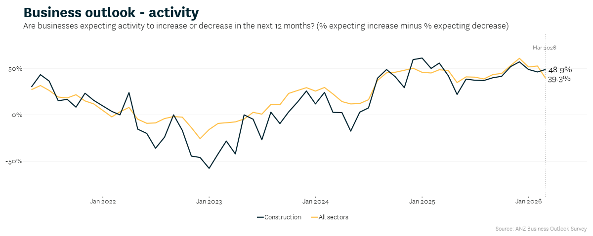
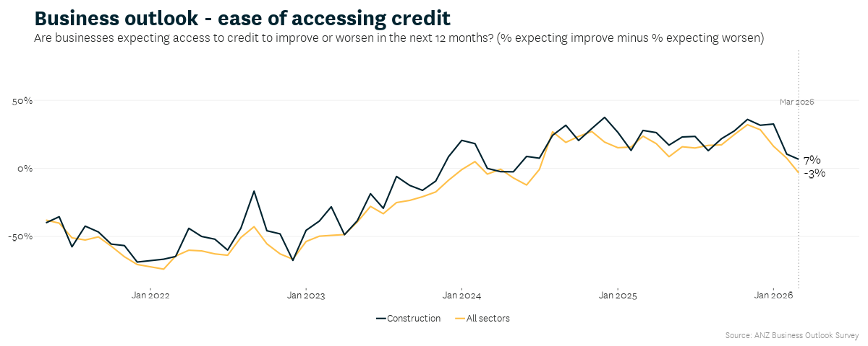
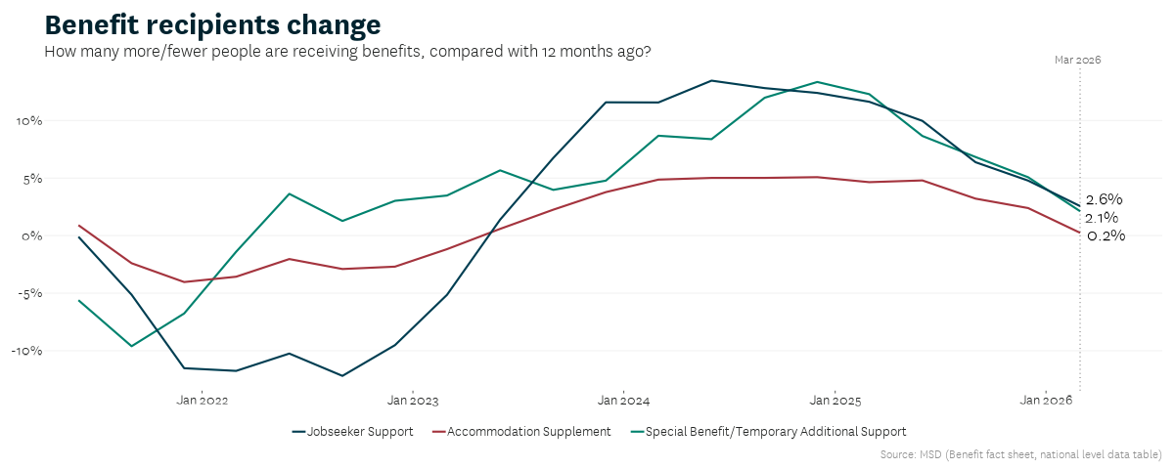

Stats NZ, December quarter 2025, Stats NZ GDP release
Stats NZ, March quarter 2026, Stats NZ CPI release
Stats NZ, December quarter 2025, Labour market statistics
Stats NZ, February 2026, International migration
ANZ, March 2026, Business Outlook survey
Stats NZ, December quarter 2025, Household living-costs price indexes
MSD, March 2026, Benefit factsheets; MSD, December 2025, Benefit factsheets
RBNZ, April 2026, Monetary policy review
Stats NZ, 17 April 2026, Selected price indexes: March 2026 | Stats NZ
The change in rental affordability indicator compares changes in rental prices for new tenancies with the growth in median household disposable (after tax) income. See Glossary for more information, pg. 09.
Crockers People & Property, March 2026, Crockers Tony Alexander Investors Insights Report March 2026
Stats NZ, 24 March 2026, Southland leads regional GDP increase in year to March 2025 | Stats NZ
For more information on HUDs analysis of rental affordability see the Housing Affordability Improved in 2025
REINZ, March 2026, New Zealand Property Report
See Glossary for the definition, pg. 09
RBNZ, April 2026, Financial stability indicators April 2026
See chart ‘High LVR residential mortgage borrowing’ pg. 16
RBNZ, Banks to ease LVR restrictions
Cotality, April 2026, Cordell Construction Cost Index (CCCI)
Hubexo, 4 Dec 2025, Construction Outlook 2026
Centrix, March 2026, Credit Indicators report
Stats NZ,01 April 2026, Building consents February 2026

