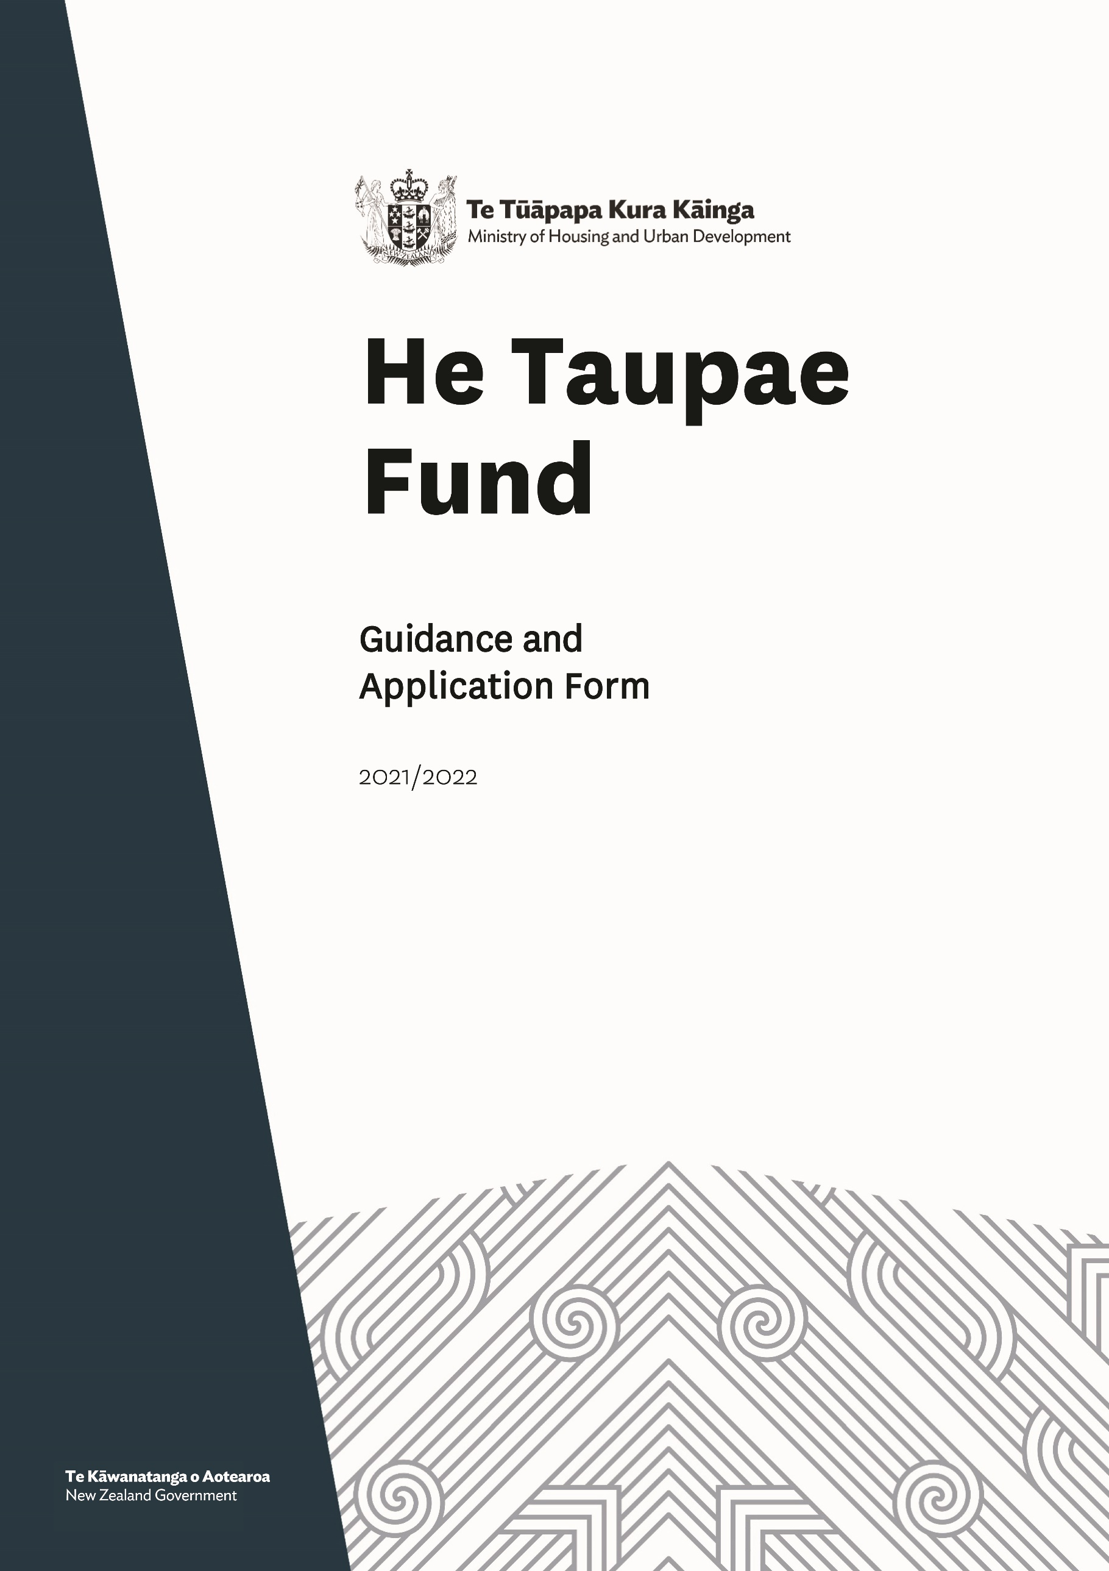
Table of Contents
Section A – Fund Information 3
Background – the Government’s commitment to Māori Housing 3
He Taupae Fund – supporting technical planning for supply 3
Criteria 4
Projects that may be funded* 5
*All consultant and contractors will need to be suitably qualified and experienced 5
Projects that will not be funded 5
How do I apply and timing to apply? 5
Due diligence 6
Level of funding 6
Late changes to the fund process 6
Next steps for successful applications 6
Questions about the Fund 6
Section B – Application to the He Taupae Fund 7
Application form 8
Site Information 10

Section A – Fund Information

Background – the Government’s commitment to Māori Housing
Te Tūāpapa Kura Kainga – the Ministry of Housing and Urban Development (Te Tūāpapa Kura Kainga) is committed to the vision that all whānau have safe, healthy affordable homes with secure tenure. Iwi and Māori-led housing developments are key to providing more homes for Māori today and into the future.
Te MAIHI o te Whare Māori – the Māori and Iwi Housing Innovation (MAIHI) Framework for Action puts Māori at the heart of Aotearoa New Zealand’s housing response, acknowledges the history of Māori housing and seeks to respond to these needs through kaupapa Māori approaches. It does this by seeking to deliver on the following outcomes:
MAIHI Outcomes
Intermediate Outcomes  Māori have access to quality and appropriate housing, and have surety of housing.  Decrease in Māori homelessness.  Increase in Māori home ownership.  Whenua Māori land potential is unlocked.  Commercial aspirations and wealth generation is realised. | High-Level Outcomes  Māori build and benefit from thriving communities and quality urban development.  Kāinga design, location, connections, conventions and retention are focused on whānau wellbeing.  Whānau are able to adopt healthy lifestyles, enjoy full participation in society, have confident participation in te ao Māori, experience economic security and active involvement in wealth creation, celebrate cohesion within the whānau and practice self-management and self-direction.

He Taupae Fund – supporting technical planning for supply
He Taupae is part of a suite of housing products made available through Whai Kāinga Whai Oranga Budget funding to support iwi, hapū and Māori entities that are looking to build houses on their whenua.
This funding can be used to access professional assistance to support the technical planning and development elements of your housing project.
Rōpū applying for He Taupae funding should have a clear vision as to what you wish to achieve on the land; be able to demonstrate demand for the size and scale of houses intended, and evidence the suitability of the site for building.
Objectives
The key objectives of He Taupae are to strengthen the:
- technical capability of rōpū to deliver warm, dry, safe, healthy and affordable homes
- delivery of kaupapa Māori focused housing supply initiatives.

Criteria
Applicant eligibility
All applicants must meet the following criteria.
- The applicant is a hapū, iwi, Māori Housing provider or Māori entity.
- The proposed houses are intended for whānau Māori including kaumātua and/or individuals.
- The housing development is non-commercial.
- The applicant has authority to build on the identified site, which is Māori owned (including General title and Māori freehold land).
Funding Criteria
Applications from eligible applicants will be assessed against the following criteria:
- Demonstrates MAIHI outcomes: The extent to which the MAIHI outcomes for whānau Māori facing homelessness or housing insecurity will be achieved
- Responds to whānau/ hapū need: The housing needs of those that the housing development will support is known (i.e. papakāinga, home ownership, affordable rentals) and funding will support planning for the delivery of this supply
- Supports sustainable Māori led housing supply: Meets the objectives of the Whai Kāinga Whai Oranga programme, with priority given to Māori led housing delivery across key placed based areas, which includes - Te Tai Tokerau, Tairāwhiti, Heretaunga, Taranaki including Central North Island, and Bay of Plenty including Rotorua
- Capability to deliver and cost effective: Describes capability and capacity to deliver the initiative (Governance, personnel, and risk management) and represents a cost-effective solution for the Government
- Provides a clear pathway to build on Māori owned land within the next two-three years and must be evidenced as follows:
Zoning:
- the proposed site must be zoned correctly for the size and scale of build
Needs Assessment:
- Evaluation of Demographics and Economics of an area – population, income, employment, average house prices, housing register numbers etc
- Existing Supply and Characteristics – housing tenure, housing stock (age/general condition), average price, average rent in area
- Specific Evaluation of Cohort – understand specific need, whānau size, employment/income, housing tenure, typology, yield, affordability
- Site Specific Analysis (high-level spatial plan) planning, constraints mapping, yield, tenure, typology, affordability
Housing Strategy:
- Vision and Aspirations
- Link to Needs Analysis – short, medium, long term(s)
- Site Selection and Evaluation (high-level spatial plan)
- High level programme
- Risk assessment

Business Case:
- Strategic Objectives (Link to Housing Strategy and Needs Analysis)
- Options analysis – housing typology, density, housing tenure, constraints/civils etc
- Cost benefit analysis
- Risk Assessment
- Partnership approach is realised through a co-contribution to the cost of the project from the applicant
- Project feasibility: The extent to which the proposed project can be progressed and delivered.

Projects that may be funded*

*All consultant and contractors will need to be suitably qualified and experienced
The types of projects that could be funded through He Taupae could include (but is not limited to):
- Development planning and management
- Feasibility assessment
- Geotechnical Investigations
- Infrastructure Reports
- Planning advice
- Contamination Reports
- Traffic Assessments
- Resource and Building Consents.

Projects that will not be funded
The following projects or items are not eligible for grant funding from He Taupae:
- capital items, including the purchase of land
- district plan changes
- existing projects, programmes or services
- duplicates of existing projects, programmes or services funded by government
- repayment or servicing of debt
- alcohol
- overseas travel
- services, activities or programmes that will be delivered overseas
- projects that are specifically intended to generate a profit. A project may generate a profit or surplus, but this must be reinvested in the project to meet the ongoing costs of the project and thereby contribute to its sustainability. Any anticipated profit or surplus must be accounted for in the project budget and be shown as contributing to the project in the future
- projects where applicants do not have land available to progress housing opportunities.

How do I apply and timing to apply?
You can apply for the He Taupae Fund by completing the below application form (in section below) and email to: TKKOAdmin@hud.govt.nz all applications must be submitted through this email address.

Due diligence
Due diligence is our way of making sure that you have the capacity and capability to fully deliver the project on time and within budget. We consider your legal status, governance and management arrangements, the organisation’s financial viability and project management plans.
If you are a registered Community Housing Provider or have Social Sector Accreditation, we factor this into our due diligence.

Level of funding
Applications for He Taupae funding may be up to $750,000.00 (excluding GST, if any). The level of contribution will be determined by the size and scale of the project, overall fit with criteria, and availability of funds.

Late changes to the fund process
Where any changes are made to the fund or application process, or if additional information is required, Te Tūāpapa Kura Kainga will advise applicants by direct email.

Next steps for successful applications
Successful applicants will be offered funding support by way of a Grant Funding Agreement. You will be required to provide regular reports as part of the monitoring process.

Questions about the Fund
Email Te Tūāpapa Kura Kainga at TKKOAdmin@hud.govt.nz if anything is unclear or you have a question about the fund or the application process. All questions and answers will be regularly updated to the Te Tūāpapa Kura Kainga website www.hud.govt.nz.

Section B – Application to the He Taupae Fund
Before completing this form, PLEASE READ He Taupae Fund Application Guidance.
- Do not paste images or diagrams into the form. If you have images or other materials you would like to submit as part of your application, please reference them in the form with clear, descriptive file names and attach them to your email when you submit your application. Please keep the total size of your email application under 10MB including attachments.
- Please be concise in your responses to the questions outlined in the form and keep to the space provided per question (one page maximum per question). A suggested maximum word count has been added to each response area.
- Delete square bracketed insertion guides as you complete the form, and ensure they are deleted for the final submitted form.
- Do not print the form out to complete any aspects manually. If you are unable to add an electronic signature to the form, we accept a typed name instead of a signature.
Submitting your application
Please email completed application forms and any supporting attachments TKKOAdmin@hud.govt.nz by 5:00pm on 11 February 2022.

Please email TKKOAdmin@hud.govt.nz if you have any questions.

Application form
Information requested | Details
Applicant name(s):
Project name:
Project Location (Address, town/city and region):
Total cost of project:
Amount requested from He Taupae Fund:
Date of application:
Your Profile
Organisation | Details
Legal name of organisation:
Trading name (if different):
Contracting entity (if applicable):
Entity type: (E.g. Charitable Trust, Incorporated Society, Company, Limited Partnership, Trust, Ahuwhenua Trust, Whānau Trust)
New Zealand Business Number (NZBN): (if relevant)
Date of Incorporation: (if relevant)
Registered Office: (if relevant)
Physical address
(if different from registered office):
GST Registered? Please provider GST number.
Do you currently hold Social Services Accreditation (SSA) Approval status? | Yes |  | No
Are you a registered Community Housing Provider (CHP)? | Yes |  | No
Are you an approved Progressive Home Ownership Provider? | Yes |  | No
Will the proposed project enable build opportunities on land either owned by your organization or on land/a site available with consent to use? | Yes |  | No
http://www.msd.govt.nz/what-we-can-do/ providers/approvals/application.html | SSA Level/registered CHP no:  Issue Date:  Expiry Date:
Details of any other Māori Housing funding in the past two years from either HUD or Te Puni Kōkiri? Provide details including year, value of funding received and purpose.
Other relevant information about the applicant: [E.g include other partners]
Aims of organisation – please describe the aims of the organisation (approx. 100 words)

Key contact person
Information requested | Details
Contact Person:
Title:
Phone number (Business):
Mobile number:
Email address:
Physical Address:
[If more than one office identify the address of office that will undertake the project]
Postal Address
Role in the project:

Site Information
Development Site | Details
Name of Development
Street Address
Legal description of Land (Lot DP)
Name of Landowner entity
Developer Entity
Zoning of land
Māori or General title land
Number of houses proposed
- Your project
Project Background
1.1 | Describe your proposed project:  - what is the need and opportunity to be addressed?  - how will this project support your long-term housing aspirations; and how does that align with the MAIHI outcomes framework?  Please keep your response to 1000 words maximum.

1.2 | How will funding be used? Please relevant boxes below
Geotechnical Investigations |  | Planning advice
Master planning |  | Contamination Reports
Infrastructure Reports |  | Traffic Assessments
Development planning and management |  | Feasibility assessment
Resource and Building Consents |  | Whānau needs analysis
Other – please state what:

1.3 | What are the key activities and timeframes for the project? Add more rows as needed.
Key Activity | Timeframe
Project start date | [please enter]
[please enter activity here] | [please enter timeframe here months/ date]
[please enter activity here] | [please enter timeframe here months/ date]
[please enter activity here] | [please enter timeframe here months/ date]
Project end date | [please enter]

- Organisational Planning and Capability
Information Requested
2.1 | How will the project be managed? Please provide details of the project governance and management structure (500 words max)

- Community Need
Information Requested
3.1 | How will the project respond to the needs of whānau in your locality? (1000 words max).  - What is the estimated number of individuals and whānau that will benefit from the project?  - What is the purpose of the intended housing? E.g. papakāinga, affordable rental homes, whānau-owned homes, Community Housing, Transitional Housing, iwi social housing etc.  - How will your project provide for the housing aspirations of whānau Māori?  - How does your project align with local / regional strategies or plans and increase the supply of warm, dry, safe, healthy, and affordable homes?

Risk management
What are the possible risks to the successful delivery of your project and how will these be managed and mitigated? Using the table below, outline the potential risk, the impact should the risk occur, the likelihood of the risk happening, and your mitigation plan.
These questions are not rated but will help to inform conditions if your grant application is successful.
HUD Risk Matrix | Impact | Likelihood | Mitigation
[Outline risk/s with low impact here] | Low | Low | [Outline mitgation for each low impact risk here]
[Outline risk/s with medium impact here] | Med | Med | [Outline mitgation for each medium impact risk here]
[Outline risk/s with high impact here] | High | High | [Outline mitgation for each high impact risk here]
- Conflict of Interest
Information Requested
4.1 | Does anyone in your organisation have an existing relationship (professional or personal) with the Ministry of Housing and Urban Development, or any of its employees, that may require managing as a conflict of interest (real or perceived)? (1000 words max)  Please include a description of any conflict (real or perceived). How will identified conflicts of interest be managed?

5. Budget details
Provide details of the budget (excluding GST) over its whole-of-life.
Activity: Item and/or supplier | Qty/Unit | Unit cost  $ (excl GST) | Total Amount  $ (excl GST)
[Please outline individual items here] | [outline quantity here] | [outline individual unit cost here] | $
[Please outline individual items here] | [outline quantity here] | [outline individual unit cost here] | $
[Please outline individual items here] | [outline quantity here] | [outline individual unit cost here] | $
[Please outline individual items here] | [outline quantity here] | [outline individual unit cost here] | $
[Please outline individual items here] | [outline quantity here] | [outline individual unit cost here] | $
[Please outline individual items here] | [outline quantity here] | [outline individual unit cost here] | $
[Please outline individual items here] | [outline quantity here] | [outline individual unit cost here] | $
[Please outline individual items here] | [outline quantity here] |  | $
 | Total Project Cost |  | $
 | Contribution from He Taupae funding |  | $
 | Contribution from your organisation  Breakdown:  [outline quantity and individual unit cost here] |  | $
 | Contribution from other sources |  | $

Applicant declaration
Please tick each section and sign the declaration as appropriate.
Tick
I confirm that the information contained in all sections of this application form or supplied in support of this application is complete, true and accurate.
I represent, warrant, and agree that I have authority to submit the application, to make the statements and to provide the information in the application on behalf of the applicant organisation.
I confirm that my organisation does not have an existing relationship (professional or personal) with the Ministry of Housing and Urban Development, or any of its employees, that may require managing as a conflict of interest (real or perceived).
I confirm this application complies with the objectives of my organisation, as contained in the organisation’s constitution, trust deed or another guiding document.
I confirm that the applicant organisation is not in receivership or liquidation and no trustees (if relevant) are undischarged bankrupts.
I understand that there is no guarantee that our organisation will be successful in securing He Taupae funding.
I have read the Whai Kāinga Whai Oranga investment framework and understand that a contribution towards the any supply project will be required from the applicant organisation (or other partner).
I agree that the HUD may collect information about my organisation from any third party (including a referee) for the purposes of evaluating this application.
I agree that information provided in this document can be used by the HUD for statistical purposes and policy development.
I acknowledge that if the application is successful, the name of our organisation, the purpose of the funding and the funding amount will be made publicly available as part of the HUD’s accountability for public funds.
I agree that if successful, our organisation and a target group of beneficiaries of the proposed project may be required to participate in an evaluation of the initiative.
I understand that if this application is approved, the project cannot commence until the Grant Agreement has been signed by the grantee and HUD.
Note: HUD cannot reimburse any costs incurred before the Grant Agreement is signed by both parties.

Signature: _______________________________________________________________
Full name: _______________________________________________________________
Role: _______________________________________________________________
Organisation: _______________________________________________________________
Date: _______________________________________________________________

Required supporting information
Please provide supporting information and any authorisation that may impact the delivery of the project.
Checklist of supporting information |  | Tick
Trust Deed or Constitution / Rules | Required
Confirmation of organisational (governance and management) structures | Required
Latest audited accounts, income and expenditure statement and a copy of the unaudited management accounts | Required
Documentation for Community Housing Provider Registration or Social Sector Accreditation | Required, if registered or accredited

Māori entities are registered businesses with a minimum of 50 percent Māori ownership or are a Māori Authority - Māori Authority.
Monetary or in-kind

